Name
Title
Organisation
Street Address
Country

30 July 2026

Invitation to the Cities Alliance Annual Meetings
30 – 31 October – 1-2 November, Hanoi, Viet Nam

Dear XXX,

On behalf of the Cities Alliance and the Urban Development Agency (UDA), Ministry of Construction, we are pleased to confirm your invitation to participate in the above-referenced Annual Meetings of the Cities Alliance, hosted by the Ministry of Construction, to be held in Hanoi, Vietnam. Special room rates have been arranged with the Hilton Opera Hanoi Hotel for Cities Alliance participants. The meetings will be held at the National Conference Center, Viet Tri City and the Hilton Opera Hanoi Hotel.

Kindly please Ms Nguyen Thi Hong Hanh on your Visa Application:

International Cooperation Department
Ministry of Construction
37 Le Dai Hanh Str., Hai Ba Trung Dist., Ha Noi, Viet Nam
Tel/Fax: 84-4-3976 0497
Att: Ms Nguyen Thi Hong Hanh
Email: honghanh0124@gmail.com

Cc: Nguyen Thi Bich Hue
Deputy Director General
International Cooperation Dept.
Ministry of Construction
Email: bichhue.moc@gmail.com

The agendas for the meetings are to be sent separately.

We look forward to your participation in this event.
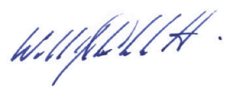
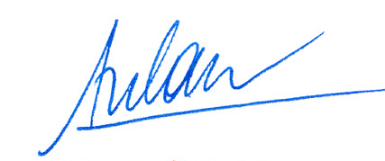
Dr. Do Tu Lan William COBBETT
Deputy Director General, UDA Manager
Ministry of Construction Cities Alliance

