AGRA CITYWIDE SLUM UPGRADING PLAN (CSUP)

Project Proposal

Submitted by

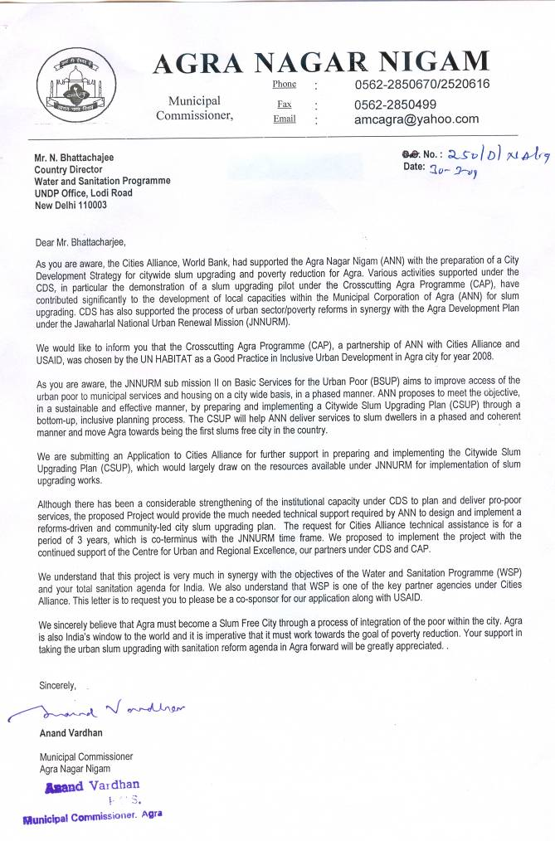
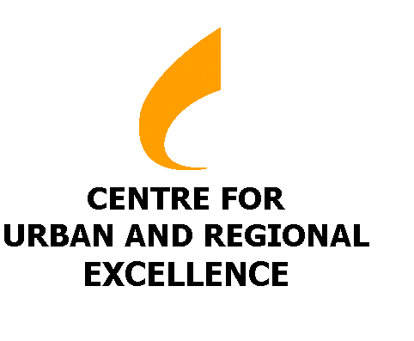

Agra Municipal Corporation A –10, Green Park Main,
Near Sanjay Place, Agra New Delhi-110016.
Uttar Pradesh, India India
Tel: 0562-2850670 Tel: +91-11-40755900,

Fax: +91-11-2696 9478 Fax: +91-11-2696 9478
Email: amcagra@yahoo.com Email: info@cureindia.org

CONTENTS

Application 3
Sponsorship Letters 4
Application Form 6
Annexures
1. Good Practice Certificate 28
2. Private Sector Contribution Under CAP 29
3. Request letter for CDS-II 30
4. Capacity Building Proposal submitted by ANN to JNNURM 31
5. CAP Outcomes 43
6. letter to UNESCO for IHCN membership 45

Letter of Application for CSUP
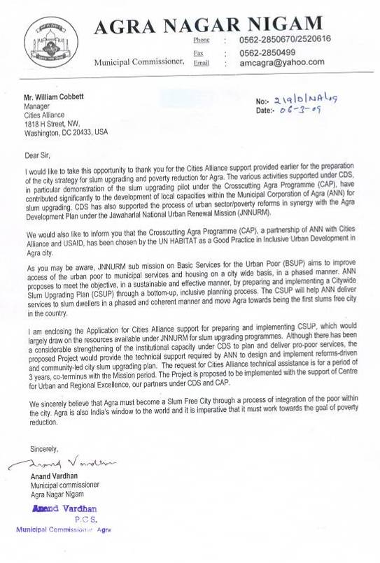

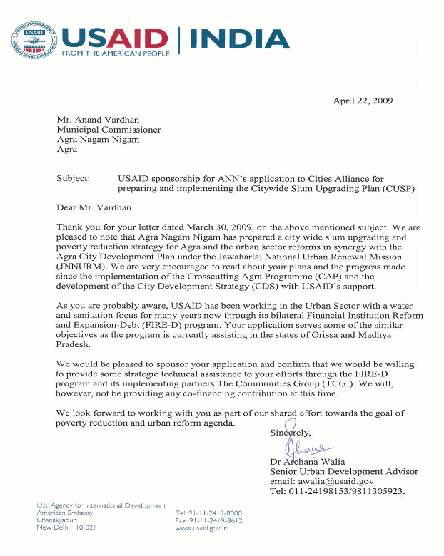
Sponsorship Letters
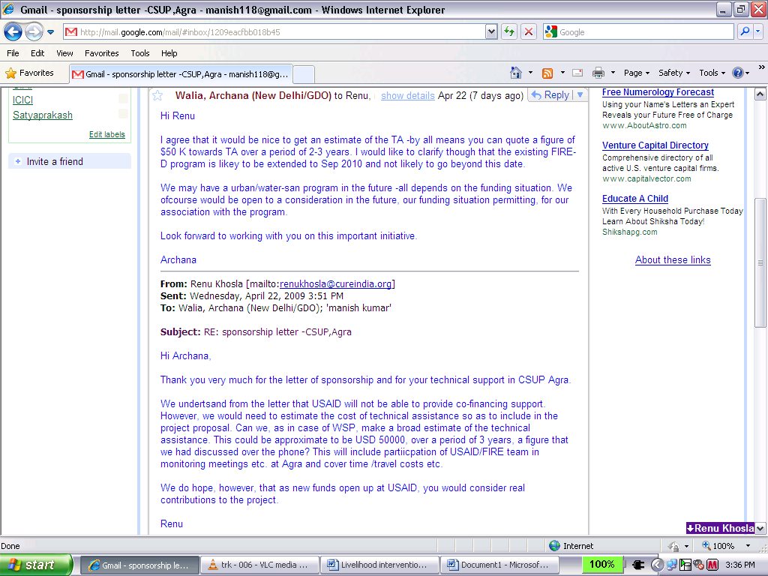

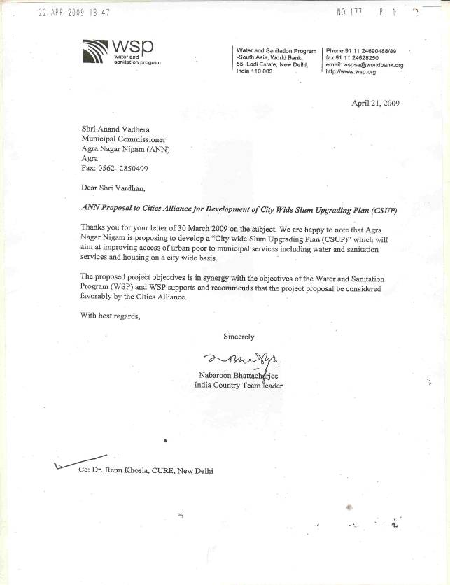
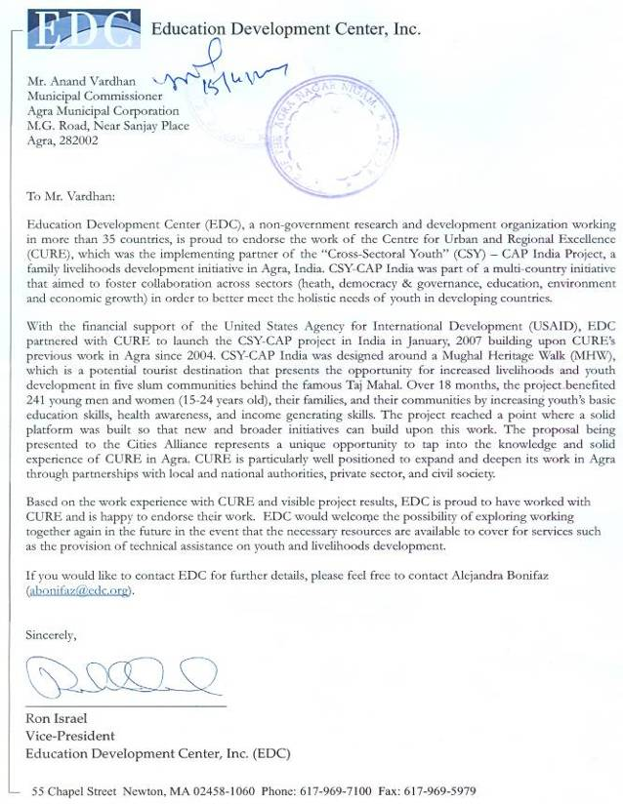


Submission of Proposals: Application Form
Please read carefully the "Guidelines for the Submission of Proposals" which outline the modalities for application and the criteria for the selection of proposals spelled out in the Cities Alliance Charter. Please ensure that all necessary supporting documentation is attached to this form. Additional information may also be enclosed, but total submission should not exceed 12 pages.

DATE: 23rd April 2009

1. TITLE of PROPOSAL: Citywide Slum Upgrading Plan (CSUP) for the Heritage City of Agra

2. PROPOSAL SUBMITTED BY:
Name and Title: Mr. Anand Vardhan, Municipal Commissioner
Organisation: Agra Municipal Corporation
Address: Agra Nagar Nigam Building, Near Sanjay Place, Agra
Telephone/Fax/E-mail: 0562-2850670, 2850499. amcagra@yahoo.com

Contact person for questions on the application: Mr. Suresh Chand
Name and Title: Executive Engineer/Nodal Officer- JNNURM
Organisation: Agra Municipal Corporation
Address: Agra Nagar Nigam Building, Near Sanjay Place, Agra
Telephone/Fax/E-mail: 0562-2850670, 09319406010. schandagra@gmail.com

3. CITIES ALLIANCE MEMBER(S) SPONSORING THE APPLICATION:
Name and Title: Dr. Archana Walia, Senior Urban Development Advisor
Organisation: USAID
Address: American Embassy, Chanakya Puri, New Delhi, 110001
Telephone/Fax/E-mail: +91 11 24198000, awalia@usaid.gov

Name and Title: Mr. N. Bhattacharjee, India Country Team Leader
Organisation: Water and Sanitation Programme, The World Bank
Address: UNDP Office, Lodi Road, New Delhi 110003
Telephone/Fax/E-mail: +91 9811068166, nbhattacharjee@worldbank.org

4. RECIPIENT ORGANISATION: – organisation that will receive and execute the grant:
Task Manager Name & Title: Dr. Renu Khosla
Organisation: Centre for Urban and Regional Excellence
Address: A-10, Green Park Pain, New Delhi 110016
Contact Person/Title: Director
Telephone/Fax/E-mail: 98 181 98612 (M) renukhosla@cureindia.org

CURE Agra Office
CAP, Room No: 313, 2nd Floor, Agra Nagar Nigam, Near Sanjay Place, Agra
Ph: 91562 3940567

5. OTHER IMPLEMENTING PARTIES (if any):
Task Manager Name & Title: Ms. Shahena Khan
Organisation: Centre for Action and Participatory planning, (CAP), Agra
Address: 174, Balooganj, Gwalior Road, Agra, 282001
Contact Person/Title: President
Telephone/Fax/E-mail: 9997349543 (M) shahena.khan@gamil.com

INFORMATION ON PROPOSED PROJECT:

- Type of project (check one):
City Development Strategy__ Slum Upgrading √ Both__

- Geographic scope of project (specify):
City: Agra, Uttar Pradesh
Country: India
Global/Regional/Multi-country: ____________

- Expected duration: 3 years

BUDGET SUMMARY:

- Amount of total budget requested from Cities Alliance funding: US Dollars 499986.66

- Co-financing amount of total budget, including local partners: US Dollars 499999.99

- Total project budget cost: US Dollars 999986.65

DESCRIPTION OF PROPOSED PROJECT:

12. Background – issues to be addressed and scope of project

- The Rationale
Agra is a global tourist destination, and offers huge potential for developing a strong and broad-based tourism-centric city economy. The road-blocks to realising the potential include the city’s poor sanitary conditions and unplanned developments that have inhibited realisation of the development prospects. The situation is exacerbated by high slum concentration and lack of concerted action to improve the environmental conditions in these settlements on a city wide scale, to make Agra both tourist and people friendly.

Poor living conditions characterise the 252 notified and 130 non-notified slums in Agra. Upgrading and mainstreaming these settlements with city systems is a critical pre-requisite for city development and to achieve economic potential of the city. The challenges of transforming Agra into a ‘City Without Slums’ include provision of social and physical infrastructure to large magnitude of slum-dwellers in the city, and facilitating improvements in their dwellings and living environments. In the perspective of the challenge, the city also offers immense opportunity to achieve the goal since 85 percent of slum households have legal titles to land.

Two slum upgrading initiatives in the city, over the past three years, are the stepping stones for developing and implementing a citywide slum upgrading plan. These are as follows:
(a) Cross cutting Agra Programme (CAP), supported by USAID and Centre for Urban and Regional Excellence (CURE), a development NGO, over the past three years, to formulate the process and create institutional capacity to implement inclusive slum upgrading. In February 2008, the Cross cutting Agra Programme (CAP) was chosen by the UN HABITAT as a Good Practice in Inclusive Urban Development. The letter of recognition is annexed (Annexure -1).

(b) Cities Alliance (CA) support to the city of Agra (CDS) for the implementation of City Development Plan (CDP), prepared under Jawaharlal Nehru National Urban Renewal Mission (JNNURM), focused on, among other things, formulation of Citywide Slum Upgrading and Poverty Reduction strategy in synergy with infrastructure investments planned under the Mission. The other initiative in the city implemented with CA support includes design of reforms mandated under JNNURM sub-mission on Basic Services for Urban Poor (BSUP) - Internal Earmarking of Funds for the Poor (IEFP), Basic Services for the Urban Poor (BSUP) and Community Participation Law (CPL).

The two initiatives have had some measure of success in improving local capacity for slum upgrading at city scale. In particular there is: better local understanding of inclusive slum development with community participation and mobilization, willingness to partner with other local agencies for synergized action and to engage with private and civil society agencies in city development. Physical construction of toilets in homes, community and school, and improved roads and drains linked to a decentralized waste water treatment system (DEWAT) in the CAP pilot has generated a demand for sanitation services in other neighborhoods. Along with appropriate technology options, the toilets have been linked to systemic changes in toilet policy around heritage monuments, paving the way for an open defection free city. CAP’s comprehensive livelihoods program with one small and one medium enterprise, skills building, access to credit, private sector engagement, integrated with Agra’s core economy tourism; has led to sustainable poverty reduction among participating households. A Community Credit Facility modeled on CLIFF acts as an instrument for micro lending and community led neighborhood development in the pilot project. Ward consultation process with representation from poor communities was also piloted under CDS with a view to develop plans to mainstream slums within the city. A Community Based Information System (CBIS) with slums and monuments mapped onto property tax maps is available for monitoring upgrading action. Private sector participation has generated some resources for ramping up infrastructure development. Agra was identified as the chair for leading the Heritage Cities Network under JNNURM for information sharing and has also applied for membership of the Indian Heritage Cities Network under UNESCO (Annex 6).

The major threats to Agra achieving the goal of a ‘City Without Slums’ however remain and are (i) split responsibility for slum upgrading between the Agra Municipal Corporation (ANN) and District Urban Development Authority (DUDA); and (ii) disconcerted and resource-intensive project-based slum upgrading approach adopted in the city rather than a long-term, sustainable and collaborative programme to achieve the goal. Slum upgrading initiatives in the city have been largely state driven (even as the 74th Constitutional Amendment Act directs that these be transferred to the local government) and confined to notified settlements - formulated and implemented without the involvement of the ANN. The disconcerted and resource-intensive approach adopted in the city is highlighted by a recent development - DUDA is in the process of preparing a Detailed Project Report (DPR) for in situ rehabilitation of 5,000 slum families in new dwellings, for funding support under JNNURM. The beneficiaries have been selected in a non-transparent manner and the proposed project does not follow a settlement based approach; the intervention of developing new housing units is not based on an assessment of low-resource based alternatives; the mandatory beneficiary contribution of 10 – 12 percent of the project cost is not based on the assessment of their ability and willingness to pay; the project is non-equitous since only a small proportion of the slum-dwellers in the city are covered under the project; and, the project design is top-down/non-participative. These issues are sought to be addressed by developing Citywide Slum Upgrading Plan (CSUP) through a consultative process involving all stake-holding agencies including ANN, DUDA, Agra Development Authority, public utilities, state departments and the people.

A Slum Upgrading Strategy (SUS) was prepared as part of CDS I, based on a participatory rapid assessment of services in all the slums (authorized and unauthorized) and prioritization of people’s needs. The SUS spelt out the guiding principles and strategy for citywide slum upgrading and its major challenges for Agra. A detailed implementation and financial plan with phasing is now required for in-situ upgrading, prepared on a case-to-case basis, using information generated through household surveys, building on current service levels, people’s investments, feasibility of linking with existing/proposed trunk infrastructure, availability of resources and outlining the potential for forming partnerships with key stakeholders.

Strong linkage between slum upgrading and citywide infrastructure investments is important for mainstreaming the poor with city systems, sustainable poverty reduction and city environmental improvement. City investments in main trunk infrastructure development need to be synergized with slums upgrading and made more inclusive. Ward-level inclusive planning processes demonstrated under CDS need to be scaled-up, institutionalized and made an integral part of urban planning for sustainable change.

City capacities to design and implement an inclusive and integrated slum and housing development programme have improved in recent years but remain imperfect. In particular, the capacity needs significant bracing to engage with community groups including youth to identify and implement the most appropriate upgrading options, design pro poor voice mechanisms, and leverage resources to fund upgrading.

This Proposal for Cities Alliance support is for preparing Reform Linked Citywide Slum Upgrading Plan for Agra and strengthening local capacities to implement the Plan, building on the lessons and achievements of CAP and CDS.

- Objectives

Key objectives of the Reform Linked CSUP for Agra are as follows:

- Formulate an inclusive and integrated Citywide Slum Upgrading Plan.

- Create an enabling environment for urban poverty and sector reforms to contribute to the planned implementation of slum upgrading on a city-wide basis.

- Strengthen local institutions and their capacities to design and implement participatory slum upgrading projects.

Sub objectives

- Build consensus among various stakeholders, including DUDA, on the city slum upgrading and poverty reduction strategy prepared earlier under CA-supported CDS.

- Develop citywide slum upgrading plan in synergy with the slum upgrading strategy and the CDP Agra.

- Recommend an upgrading strategy for each slum settlement based on situation analysis in the settlement including its legal status, level of services and environment, quality of housing stock, preferences of the community and its willingness and ability to pay, among other things, drawing on the CA knowledge base on successful global practices.

- Prepare an inclusive city wide slum upgrading plan, and a prioritised and phased road map for its implementation, adopting a consultative approach involving various stakeholders including ANN, DUDA, Agra Development Authority, public utilities, social welfare departments and the community, including youth groups.

- Facilitate the process of restructuring municipal norms for service delivery in the poor communities and for housing the poor.

- Assess the slum upgrading needs in terms of infrastructure and social services, and improvement of existing/development of new slum housing, based on revised norms, estimate the investment requirements and, prepare a resource mobilisation plan, focusing on use of grants and borrowings to leverage local resources for citywide slum upgrading including local revenues and beneficiary contributions.

- Develop local capacity (ANN, DUDA, PIU) for the development of inclusive Detailed Project Reports (DPRs) for housing and slum upgrading, and review these within a human rights framework for equitable access to services.

- Support the preparation of various city level inclusive policies for delivery of services so as to seamlessly link in with the citywide slum upgrading plan.

- Initiate the formation/strengthening of partnerships with other local agencies, private sector, civil society for inclusive planning and implementation of slum upgrading actions and governance reforms.

- Methodology and sequencing of activities

The approach to the Project will be inclusive (participatory and integrated), sustainable and aimed at formulating CSUP and creating local capacities for its implementation, including engaging with slum communities. The Project Implementation Unit (PIU) set up within ANN for implementation of JNNURM will be strengthened to facilitate bottom up planning processes under CSUP. Ward consultation process with representation from poor communities, piloted under CDS, will be scaled across the city to identify problems and find best fit solutions. Community stakeholders, especially women and youth will be mobilised and organised to participate in the process of preparing the CSUP. Involving youth in the preparation of CSUP would serve as a catalyst for greater community participation and it will contribute to overall development of youth skills in leadership and the promotion of positive behaviour towards development initiatives. Area and Ward level committees will be facilitated /federated, with institutionalised voice mechanisms for interacting with local officials for convergence of community-based plans into citywide upgrading plans and budgeting framework. People-Public-Partnerships will be the approach for planning the implementation of physical works within slums using a range of instruments - cooperative formation, community contracting, community-based management systems, among others.

Participation of key actors and implementing agencies will be critical to implementing CSUP. Even as the city government will be the key actor in project implementation, the State government will participate through its state agencies located in Agra - DUDA, UP Tourism, State Transport Agency, among others. State facilitation will be essential in addressing key upgrading concerns such as on land tenure, community participation, etc. Engagement of the central ministries of Urban Development, and Housing and Urban Poverty Alleviation will be through the linkage of CSUP to JNNURM.

Partnerships will be forged with other local and state departments/agencies to converge a comprehensive set of services on to the poor including education, health, social, cultural, economic and recreational. Partnerships with the private sector, in particular in tourism sector - the key economic driver, initiated under CAP and CDS, will be broadened and deepened for slum upgrading and local economic development as also environmental improvement.

The effort will be to synergise CSUP with the macro framework of CDP under JNNURM, albeit with mechanisms for synergising citizen aspirations with local developmental objectives. In turn these will guide city investment priorities, seek viable financing options and appropriate investment linkages. An integrated approach to upgrading will ensure that slum settlements are networked to main trunk infrastructures for creating a sustainable city.

The approach will also be reform linked - besides supporting ANN with the implementation of the reform strategies recommended under CDS, the effort will be to establish linkages between other governance reforms, to make these poor-gender centric.
CSUP Approach:
- Universal Coverage: All Slums notified and non-notified to be included for slum upgrading with a time frame for implementation.
- Mainstreaming and networking: All poor settlements to be integrated with city systems - physically, economically and socially.
- Access in service delivery: Universal access to services, including water, sanitation and solid waste management, among others, and service level and delivery norms based on preferences of the community groups and people’s ability and willingness to pay.
- Inclusion and participation of people in preparation and implementation of upgrading plans.
- Creating an enabling environment through appropriate legal, administrative, socio-political instruments and reforms for slum upgrading investments.
- Provision of resources through effective fiscal management, public private partnerships, convergence of various government initiatives, people’s contribution for implementing slum upgrading at scale.
- Convergence with poverty reduction agenda to enable poor to develop the means to pay and access better quality and appropriate services.
- Outcome monitoring to ensure last mile connectivity.

Sequencing CSUP Activities

Formulating CSUP

- Build consensus on the poverty reduction and slum upgrading strategies formulated earlier under CAP and CDS, involving ANN, DUDA and other local agencies and state departments, and the planning framework for preparing CSUP in the context of the various initiatives being taken in the city under JNNURM.

Inclusive and Integrated Planning

- Grassroots level consultations (charades and workshops) organised across the 90 wards, in association with local elected representatives to identify key local priorities and area concerns. While the initial consultations will be led by CURE, over time, the PIU team will be enabled to become the lead player in community consultations.
- Sample household survey in select representative settlements and rapid participatory appraisals and community mapping exercises, with women, men and young people in all slums (notified and non-notified), will be used to determine priorities within slums for physical and social infrastructure, house upgrading and livelihoods, and communities’ willingness to participate in community action to improve access to services and the housing stock. The primary database and Participatory Learning and Action (PLA) processes will result in slum upgrading plans for each settlement. PIU team, with support of Community Organisers appointed by ANN, will facilitate the community consultations.
- Housing plans will be a key component of slum upgrading planning for settlements where tenure issues are unambiguous and land titles are clear. Housing designs with investment plans will be developed through community consultation processes assisted by PIU staff. Household affordability, access to housing credit, subsidies, systems for community contracting, etc. will be built-into the plans for housing and integrated within the overall CSUP.
- Area and Ward level committees will be facilitated/federated, with institutionalised voice mechanisms for interacting with local officials for convergence of community-based plans into citywide upgrading plans and budgeting framework
- Information from community and ward consultations/plans will be geo-mapped onto the city wide Community Based Information System (CBIS) developed under CDS. A map of projects and development pathways under JNNURM, YAP II, social sector projects etc. will be layered on to the CSUP-CBIS for a spatial analysis and for phasing slum upgrading and networking.

Integration with Urban Sector and Social Sector Plans

- Interactions with various urban development agencies such as the Agra Jal Sansthan (AJS), Agra Jal Nigam (AJN), Agra Development Authority (ADA), Public Works Department, (PWD), UP Tourism etc. will be continued through the various Task Forces formed under CDS. These will be critical for the formulation of the CSUP and its subsequent implementation in a coordinated /comprehensive manner. New partners, among others, will be the Transport Authorities (National Highway Authority of India, UP Bridge Corporation and Road Transport Office, etc.) for integrating transport related plans within CSUP.
- Consultations with social development agencies, facilitated by ANN, will be used for integrating social sector interventions within CSUP, such as health (National Urban Health Mission- NUHM) and education (Sarva Shiksha Abhiyan-SSA) for a comprehensive reduction in city poverty. CSUP-CBIS will also map education and health intervention planning.

CSUP and Financial Investment Plan

- The series of consultations will result in the design of the CSUP, which will include a short term plan for quick win solutions to sanitation such as for creating an Open Defecation Free (ODF) Agra; and a longer term, comprehensive plan that will address the wide-ranging issues such as access to basic services, housing, livelihoods, credit, etc.
- CSUP will be a dynamic/futuristic plan. It will, therefore, include plans for social housing of new migrants to prevent development of new slums in the city. These will include design of credit schemes that will enable poor to access loans/ amortized payments for own housing.
- A Financial Investment Plan will be prepared with prioritisation, phasing and implementation time frames. The Financial Plan will examine need and access to resources for city wide slum upgrading, including people’s contributions. Financial planning process will be both participatory and gender based for pro poor gender friendly budgets. The Financial Plan will also include social and gender auditing plans.

Implementing Upgrading

- Sample surveys using reliable and valid sampling methodologies will be undertaken to create a project baseline on key output and outcome indicators. Unlike the SUS slum mapping study wherein qualitative information was generated using rapid assessment tools for preparing the strategy, the present baseline will be based on reliable data generated from sample household survey. Baseline will be developed on key environmental indicators to assess impacts at the end of the project.
- Community slum upgrading plans, prepared using PLA techniques, will be converted into physical plans with the technical assistance of CURE. Consultations with engineers from ANN, AJS and AJN will be used to review the existing network maps and transferred on to GIS to understand feasibility of connecting to access to trunk infrastructure for mainstreaming.
- ANN and DUDA will be assisted with the preparation of DPRs including costing. The DPRs will be prepared by Wards/ clusters /development corridors and will include the comprehensive range of designs/ proposals needed for slum upgrading; basic services, housing, social sector interventions, livelihood needs, etc. The effort will be to design spaces and economic infrastructure in keeping with the nature of livelihood activities of poor people. The DPR will be submitted to JNNURM for accessing resources for implementation.
- To build the capacities of local agencies to implement community-led upgrading projects, the Project will handhold and walk them through the process of implementing ward-wide upgrading. One or more ward(s) will be selected in consultation with ANN and DUDA. The ward upgrading plan will be formulated on the basis of community consultations and information gathered in the formative stage and will contain plans for housing, services, schools, health care, economic development, transportation, solid waste management, etc.
- Housing/upgrading designs will be developed through community participation and will eventually serve as the models for preparation of low-income housing plans in the city. Housing designs will provide for spaces that enable poor people, especially women to exercise their right to decent livelihoods and to use homes as work spaces.
- The DPR will be supported by an Implementing Upgrading Primer with a simple, step-by-step approach to undertaking inclusive upgrading. It will describe community organisation processes (housing cooperatives, SHGs, community development committees), assess peoples’ ability and willingness to pay for upgrading / housing, suggest mechanisms to access housing/upgrading credit through formal (banks) and informal (deepening of the Community Credit Fund set up under CDS) instruments and address livelihood and social needs of poor people through convergence and civil society engagement. The viability of undertaking civil works under slum upgrading through community contracts/management systems would be assessed. The households’ contribution to slum upgrading would be based on affordability analysis.
- A key component under CSUP will be the promotion of sustainable livelihoods for slum dwellers linked to city economic development planning. Heritage trails, micro and business enterprises, and work force programmes initiated under CAP will be extended. Livelihood interventions are intended to enhance ability of people to contribute to slum and housing upgrading, and to meet the cost of maintenance and services of the upgraded unit.
- Upgraded slums need to be de-notified and integrated with city systems. This process will be initiated under the Project.

Capacity for Implementing Participatory Upgrading and Reform

- The project will also support the implementation of the reform documents prepared under CDS I. ANN will be facilitated to establish Urban Poverty Fund as required for implementation of Sub-mission on BSUP, IEBP, revision of service delivery norms to poor communities on an equitable basis and setting up of Area and Ward Committees under the Community Participation Law. All BSUP reforms mandated/agreed under Memorandum of Agreement between ANN and Ministry of Housing and Urban Poverty Alleviation (MOHUPA) will be structured through a consultative process.
- Governance reforms initiated under JNNURM will be reviewed with ANN/other local bodies such as user charges, property titling, grievance redressing, etc. and restructured with appropriate links to make these more responsive to the needs of poor in the city.
- Even though land tenure is not a critical roadblock for implementing citywide slum upgrading in Agra, around 15% of the slum-dwellers do not have secure tenure. CSUP will examine tenure issues in service provision and design appropriate solutions. Notification and de-notification of upgraded settlements will be built into CSUP and ANN will be assisted in the development of objective/transparent criteria for de-notification of upgraded settlements.
- As part of JNNURM-BSUP, the city is expected to develop several policies such as a City Sanitation Policy. Efforts will be made to integrate various policies under CSUP for a seamless approach to slum upgrading in the city.
- A capacity building plan has been prepared for ANN under CAP. ANN will be assisted in the implementation of the capacity building plan targeted at local field functionaries and senior officials with the objective of better planning and managing services in slums and underprivileged communities. The process of formulation and implementation of CSUP will have the full involvement of ANN, DUDA, PIU, the community organizers, etc. and will ensure sustainable capacities for implementing upgrading at scale.

Addressing Environmental Challenges

- The CSUP, through its focus on water, sanitation, waste water disposal, transport planning, will contribute to addressing environmental challenges in Agra. Special emphasis within CSUP will be on measuring environmental impact of slum upgrading. Environmental impact assessments will be undertaken for the Implementation Ward to ensure upgrading activities have minimal impact on the environment. In the CSUP, settlements that are untenable due to environmental factors will be provided with mitigation measures.

Monitoring and Evaluation

- The CBIS prepared under CDS will be developed as an instrument for planning and monitoring upgrading on a city wide basis. A Management Information System will look at the steps in the slum upgrading and monitor spatially, achievements under CSUP.
- Community based monitoring and social audit mechanisms will be designed into CSUP with local capacities to ensure greater transparency /accountability. Slum upgrading activities will be monitored at several levels. Community Based Organizations and Ward Committees will oversee upgrading processes in their settlements and Wards. A feedback loop will be created between ANN, DUDA and the communities on slum development. The PIU with DUDA will be responsible for overall monitoring of slum upgrading activities and will undertake social and gender project audits.
- The Baseline data developed through the household survey will be used for making end of the project impact evaluation against selected indicators.

The proposed activities under CSUP are depicted in the flow chart given below:

Validating/consensus building on city wide SUS with key stakeholders
Ward level plans through ward consultations

Community consultations for slum upgrading planning with housing across at wards
Re prioritizing slum and poverty concerns
Spatial analysis and integration on CBIS
Restructure and strengthening Task Forces/steering committee set up under CDS

Integrating with health, education, social welfare plans
City Slum Upgrading Plan with Financial Investment Plan
Integrating with sector plans
Short term-quick win Plan
Longer- term comprehensive plan
MIS with CBIS to monitor slum upgrading
Developing project base line on key indicators
Policy on De-notification of slums
Support for implementing ANN’s capacity building plan
Reform Implementation
Linkages with governance reforms
Policy on security of tenure

Development of Slum Upgrading DPRs
Implementing upgrading projects
Participatory and gender budgeting
Urban Livelihood development
Social audit

Institutional Arrangements for City Slum Upgrading

Sustainable institutional arrangements will be critical for ensuring upgrading continues beyond project period. Ward committees with representation of slum communities, marginal groups, women, youth etc. formed during the process of Ward Consultations will cascade into a Citywide Slum Development Committee (CSDC) to sustain a coherent dialogue at city level between urban poor and the municipal government. The slum partnership model successfully tested in Delhi by the Delhi Government and CURE (Bhagidari-Sanjha Prayas) will be adapted for replication in Agra.

The institutional arrangements initiated under CDS have included the constitution of a Steering Committee headed by the District Magistrate with Municipal Commissioner as the member secretary and 9 Task Forces to examine various sector interventions. These will be broadened and deepened under the Project. Representatives of CSDC will be included in the steering committee. DUDA, a key actor in BSUP implementation, will become a core stakeholder along with ANN under CSUP. The Steering Committee will be provided technical inputs through project partners; WSP and USAID.

Partnerships between the various social departments will be formalised at all levels of governance; steering committee (with representation of senior officials), Task Forces and community level functionaries. Partnerships will also be formalised with private sector for slum upgrading and poverty reduction.

Horizontal Knowledge Share
Lessons from CSUB will be shared with other cities through the CA and WSP supported slum upgrading plan for 5 cities and vice versa. CSUP learnings will also be exchanged with all JNNURM cities through the NIUA managed PEARL network. CURE, as consultant to Delhi Government’s participatory governance programme, Bhagidari, will facilitate the process of developing a citywide slum upgrading implementation plan for Delhi. CURE will use lessons from the USAID assisted Citywide Slum Upgrading Implementation Plan for Bhubaneswar city, that it is currently supporting, for Agra.

15. Deliverables

- A reform linked citywide slum upgrading plan with a prioritised/phased investment plan, livelihood plan, social sector interventions and social housing plans.
- Facilitating key stakeholders to prepare DPR for ward-wide slum upgrading project.
- Slum upgrading projects implemented in one Ward to demonstrate the process/approach to implementing the Plan.
- Capacity of local agencies strengthened and facilitating inputs provided to implement the CSUP in a phased manner.
- Implementation of BSUP reforms designed under CDS.
- ANN with adequate capabilities to engage with poor communities for preparing DPR for slum upgrading planning and implementing slum upgrading on a city wide basis and in a sensitive manner.
- Establishment of mechanisms for community-local body interactions.
- An MIS integrated with the CBIS on a map based platform for planning and monitoring service delivery in slums.
- Community based operation and maintenance plans/monitoring systems.
- One Environmental Impact Assessment Report with mitigation plans
- One social audit report.
- One participatory gender budget.

16. Expected outcomes and related monitoring indicators and plans

Key outcomes of the Project include:
- An Implementation Plan to upgrade 1,40,000 households in 252 authorized slums and 126 unauthorized slums in the city, to be reached in a phased manner over a 10 year period.
- Significant reduction in poverty level of 2,000 poorest households, participating in the demonstration component, through slum upgrading works and livelihood interventions through the project. An additional 10% of the poor benefit from physical infrastructure provisions by the ANN facilitated through the project during the project period. Furthermore, nearly 30% poor become aware of their rights to municipal and social services through the Ward consultations.
- Increase in enrolment, retention and learning achievements among children from upgraded settlements.
- Reduction in sanitation and water based illnesses in upgraded settlements and at the Ward level; significant reduction in health costs among poor families.
- Sustainable mechanisms for participatory planning /implementation within ANN.
- A strengthened and reform oriented PIU, with capability for inclusive/integrated slum upgrading planning/ implementation in the city.
- Private sector contributions to slum upgrading.

Monitoring Indicators

Household Level | City Level
- Per capita HH income  - Income of women  - Number of people with regular incomes, by gender  - Number of houses with private toilets  - Reduction in open defecation  - Number of houses with private /paid water taps  - Number of pucca houses  - Ownership of assets (recreation and production)  - Cost of health care  - Number of working days lost to illness  - Increase in expenditure on food  - Reduction in anemia among women and young girls  - School enrollment, by gender  - School retention, by gender  - Membership in community associations, by gender  - Participation in planning meetings, by gender  - Participation of youth in slum upgrading activities | - Increase in number of paid household water connections  - Increase in user cost recovery  - Reduced time in responding to grievances  - Visible improvement in sanitary and environment conditions

17. Sources of investment to implement the CDS or slum upgrading programme

The resources for investments in slum upgrading would be mobilised from households; municipal (pro-poor head) and DUDA budget for non-notified and notified slums, respectively; and grants from state government (state share in contribution under JNNURM) and national government (JNNURM).

Co-financing for the Project: The matching funds for the Project (to those provided by CA) would be mobilised from the ANN capacity building budget, besides ANN contributions in kind in terms of staff time and office space. ANN is also committed to fund the infrastructure development such as community toilets, waste disposal systems etc. from within municipal budgets. 20 percent ANN budget is earmarked for slum development under BSUP reforms.

The scope of the Project includes estimation of resources required for citywide slum upgrading and prospects of mobilising funds from various sources as follows:

- JNNURM resources for implementing physical upgrading works. Agra is well positioned to access JNNURM resources, especially under BSUP housing. As the pace of implementation of projects under JNNURM picks up, the likelihood of more resources flowing in for slum upgrading would be higher.
- Sector level contributions through various programme, accessed through a process of convergence.
- The city can access up to Rs.600 crore or USD 130 million from the Taj Trapezium Fund and Rs. 300 crore (USD 65 million) from a tax called Pathkar levied on tourists visiting the Taj against approved proposals. A key task under the Project will be to unblock and streamline the flow of the share of resources to ANN from these funds through support in preparation of proposals to release the funds.
- Capacity building funds provided to ANN under JNNURM. ANN has submitted a proposal for Rs 1.59 crore (around US $ 350,000) for capacity building activities under JNNURM. The entire budget will be used for implementing CSUP.
- Resources will be accessed through convergence under the health programme of USAID, the National Urban Health Mission. USAID has Rs 14 crore or USD 3 million allocated for urban health initiatives in Agra to address slum health needs. Convergence with government programmes such as the Sarva Shiksha Abhiyan (SSA) will provide complementary funding for formal education.
- The state funds available under education and health would also be dovetailed for slum upgrading.
- The Tourism Guild comprising major hotels and city tour operators has been a major partner under CAP-CDS. Their contributions under the project have been estimated at Rs 3,05,000 or USD 6,721 (Annexure-2). Private sector engagement will be deepened to generate more resources under the project and to contribute to improvements around heritage sites, promotion of heritage walks, provisioning of signs, street furniture, landscaping, toilets, shop frontages, etc.
- In addition, feasibility of PPP model (using incentive FSI mode) would be assessed.

18. Partnerships

Partnerships with other local and sector agencies will be at the core of preparation and implementation of CSUP. ANN will work in close association with DUDA, PWD, ADA, transport authorities, AJS, AJN, etc. in the design and implementation of CSUP. These agencies have largely complemented CAP and CDS projects. Specific focus, however, will be to institutionalise the partnerships for long term sustenance.

Partnerships will also be developed with the state departments of health, education, welfare, women and child development, public distribution, among others to dovetail poverty-focused programmes of central and state governments with the CSUP.

The Project would create enabling environment for PPP in slum upgrading to improve the effectiveness of service delivery and poverty reduction in Agra.

CSUP will also identify and work closely with local NGOs and civil society groups for larger involvement of communities in scaling up interventions and its sustainability. Active youth groups at the community level will also be associated for a greater participation in planning and slum improvement activities.

CURE, the lead partner of ANN in the implementation of CAP and CDS projects, will facilitate stakeholders in developing sustainable partnerships for slum upgrading on a city wide scale. The CURE-ANN partnership has created an enabling environment within the ULB for NGOs engagement in slum upgrading. Efforts will be made to develop and institutionalise systems for sustained engagement of the civil society in the implementation of CSUP.

The partnership with utility services, including AJS and AJN, will ensure inclusion of slum settlements in city-wide infrastructure development projects, linking the informal settlements with network services and transport corridors.

- Government commitment and approval

ANN has developed this proposal for CA support for formulating and implementing CSUP and the municipality was earlier an equal partner in implementing CDS and CAP projects. The project offices of CAP and CDS were located in the ANN office and the municipality had drawn heavily from the projects and the team for technical assistance in undertaking urban reforms. It has provided continued support for engaging the Task force and forging partnerships for slum upgrading and poverty reduction initiatives besides leading the community mobilisation efforts for preparing and implementing the community-driven plans.

ANN-led activities under CAP and CDS include financial allocations for slum upgrading works, including construction of community toilets and pathways in project settlements; dialogue with Archeological Survey of India (ASI), which is responsible for conservation of heritage buildings in the country, for construction of the decentralized wastewater treatment system and renovation of toilets for improving the waste water quality/sanitation conditions in the settlements close to Taj Mahal; community engagement and consensus building for physical works in slum settlements, including construction of school toilets; facilitated interactions among various stakeholders, including development and social sector agencies, state departments, district agencies, industrial associations, private sector, civil society, among others, on various city development issues. The district administration targeted resources to poor communities through the CAP agencies and this was an official recognition of the Project’s contribution to slum and community development. Under CAP, youth groups have been involved by local and state authorities in the conveyance of their health and social messages across the city.

ANN has requested Cities Alliance for a second phase of support for implementation of BSUP reforms and slum upgrading strategies. The letter is annexed (Annexure -3).

National and state government approval is not required for implementing the citywide slum upgrading plan since slum upgrading function has been assigned to ANN under the 74th CAA. The state government concurrence may, however, be a facilitating input, as mentioned above. In the case of Uttar Pradesh, the state government has already shown its commitment to granting land titles. Besides the city commitment to the Project, as is evident from the letter from ANN, the state government commitment to the citywide approach would be through participation of DUDA and is also demonstrated in its commitment to the reforms process by way of the tripartite agreement with MoUD under JNNURM. The national government is committed to the approach under JNNURM in all the mission cities including Agra.

- Implementation arrangements

The project will be implemented with the support of the Centre for Urban and Regional Excellence (CURE), the development NGO that has been the lead partner of ANN for the implementation of CAP and CDS. CURE has been provided office space within the ANN premises for the implementation of the projects.

The PIU within ANN will be the implementing partner. PIU will work under the supervision of the Executive Engineer and Nodal Officer, JNNURM and accountable to the Commissioner ANN.

At ANN a Slum Upgrading Committee will be set up with representation of DUDA and key agencies for the design and implementation of CSUP. The CSUP Committee will report to ANN Commissioner and the City Steering Committee. Steering committee will receive technical support through WSP and USAID. The latter agencies will also help to promote Agra’s upgrading agenda within the state and national development agencies through its existing partnership arrangements.

Project oversight will be through a joint monitoring committee comprising the CA, USAID and WSP. ANN/CURE will provide regular feedback and mandatory reports as per CA protocol. Monitoring will also include site visits to Agra, participation in the Steering Committee meetings.
Project Schedule | Time Line
Project Schedule | Q1 | Q2 | Q3 | Q4 | Q5 | Q6 | Q7 | Q8 | Q9 | Q10 | Q11 | Q12
Preparatory activities
City consultation to build consensus on SUS and vet the approach for developing CSUP | ●
Restructuring task forces /steering committees, integrating new partners | ● | ●
Inclusive and Integrated planning
Ward level consultation (charades/workshops) in 90 wards and developing ward level plans |  | ● | ● | ●
Baseline survey |  | ● | ●
Community mapping with slum dwellers and preparing slum upgrading plan for each slum |  | ● | ● | ●
Developing housing plans through community consultation |  |  | ● | ●
Integrating information collected from ward/slum consultation into CBIS |  |  |  | ●
Consultation with implementing agencies of JNNURM/YAP-II and spatial analysis of development projects and pathways |  | ● | ●
Integrating urban and social sector plan

Consultations with sector development agencies to plan for integrated slum upgrading |  |  | ● | ●
Consultation with social development agencies to integrate social interventions in CSUP |  |  | ● | ●
CSUP & Financial investment plan
Finalization of CSUP |  |  |  |  | ●
Agreeing upon the financial investment plan |  |  |  |  | ●
Project schedule and delivery targets: A detail of project schedule and the anticipated delivery targets for the CSUP process is summarized below:-
Project Schedule | Time Line
Project Schedule | Q1 | Q2 | Q3 | Q4 | Q5 | Q6 | Q7 | Q8 | Q9 | Q10 | Q11 | Q12
Implementing slum upgrading

Ward level multi stakeholder workshops/charades |  |  |  |  |  | ●
Participatory planning with slum communities |  |  |  |  |  | ● | ●
Developing ward wide slum upgrading roadmap with step wise approach for inclusive upgrading |  |  |  |  |  |  | ●
Preparing housing designs using PLA techniques |  |  |  |  |  |  | ●
Preparing integrated DPR for slum upgrading for the demonstration ward |  |  |  |  |  |  | ●
Community mobilization and stakeholder engagement |  |  |  |  |  |  | ●
Implementing physical construction work through community contracting systems. |  |  |  |  |  |  |  | ● | ● | ● | ●
Conducting an affordability analysis and setting up the Community Credit Fund |  |  |  |  |  |  | ● | ●
Organize experience exchange meetings |  |  |  |  |  | ● | ● | ● | ● | ●
Livelihood interventions (heritage trails, business enterprise, works force programs) |  | ● | ● | ● | ● | ● | ● | ● | ● | ● | ●
Private sector partnerships |  | ● | ● | ● | ● | ● | ● | ● | ● | ● | ●
Participatory and gender budgeting |  |  |  |  |  |  |  |  | ● | ●
Social audit |  |  |  |  |  |  |  |  | ● | ●
Implementing participatory upgrading and reforms

Supporting implementation of Poverty reforms |  |  |  | ● | ● | ● | ● | ● | ● | ●
Restructuring governance reforms |  |  |  |  |  |  | ● | ● | ● | ●
Setting up area committees /ward committees under CPL |  |  |  |  | ● | ●
Developing roadmap/policy/criteria for denotification of slums |  |  |  |  |  |  |  |  |  | ●
Preparing policy on security of tenure |  |  |  |  |  |  |  |  |  | ●
Assisting ANN in implementing capacity building plan |  | ● | ● | ● | ● | ● | ● | ● | ● | ● | ● | ●

Project Schedule | Time Line
Project Schedule | Q1 | Q2 | Q3 | Q4 | Q5 | Q6 | Q7 | Q8 | Q9 | Q10 | Q11 | Q12
Environment Impact Assessment Study |  |  |  |  |  |  |  |  |  | ● | ●
Management Information System
Setting up of MIS linked with CBIS |  |  |  | ● | ● |  |  |  | ● | ●
Designing community based monitoring and social audit mechanism |  |  |  |  |  | ● | ●
Impact assessment |  |  |  |  |  |  |  |  |  |  |  | ●
Advocacy
Dissemination/Lessons learnt workshop to share experiences with other NURM cities |  |  |  | ● |  |  |  | ● |  |  |  | ●
Newsletters, website, other advocacy material |  | ● |  | ● |  | ● |  | ● |  | ● |  | ●

Financing plan

- CITIES ALIANCE GRANT REQUEST

Components / Main Activities | Total  (US$) | Type of Expenditure
Components / Main Activities | Total  (US$) | Consulting Services  (US$) | Training/ Capacity Building  (US$) | Dissemination Costs  (US$) | Other  (US$)
PROJECT ACTIVITIES:
City Consultation to launch CSUP | 3,944.44 | - | 39944.44 |  | -
Grassroots level workshop and developing ward level plans for (90wards) | 133,000 | - | 133,000 |  | -
Baseline Survey | 12,66.67 | 6,111 | 6,556 | - | -
Community Mapping | 21,203.33 | 7,111 | 14,092 | - | -
Housing Development plan | 10,311.11 | 8,222 | 2,089 | - | -
Meetings with JNNURM/YAP-II implementing agencies and spatial analysis | 4,311.11 | - | 4,311 |  | -
Task Force meetings | 6,788.89 | - | 6,789 |  | -
Steering Committee Meeting | 4,133.33 | - | 4,133 |  | -
Meeting with Social Development Agencies | 3,588.89 | 2,289 | 1,300 | - | -
Designing CSUP | 11,022.22 | 8,222 | 2800 |  | -
Developing ward wide slum upgrading road map | 13,472.22 | 6,911 | 6,561 | - | -
Preparing Housing Design | 7,477.78 | 5,622 | 1,856 | - | -
Preparing integrated DPR for slum upgrading for the demonstration ward | 5,944.44 | 5,222 | 722 | - | -
Implementing physical construction work in the ward | 46,566.67 | 4,289 | 42,278 | - | -
Affordability analysis for micro finance assistance | 3,777.78 | 3,378 | 400 | - | -
Experience exchange meeting | 27,444.44 | - | 27,444 |  | -
Initiating livelihood interventions | 6,888.89 | 6,222 | 667 | - | -
Meetings with private sector agencies | 3,777.78 | - | 3,778 |  | -
Gender budgeting in demonstration ward | 4,111.11 | 3,733 | 378 | - | -
Social audit in the demonstration ward | 4,666.67 | 3,289 | 1,378 | - | -
Establishing Urban Poverty Fund in ANN | 8,122.22 | 5,044 | 3,078 | - | -
Setting up area committees /ward committees under CPL | 4,977.78 | 4,311 | 667 | - | -
Revision of service delivery norms for BSUP | 4,955.56 | 3,845 | 1,111 | - | -
Reviewing governance reforms and restructuring | 4,666.67 | 3,556 | 1,111 | - | -
Developing roadmap/criteria for denotification of slums | 4,333.33 | 3,777 | 556 | - | -
Developing policy on security of tenure | 2,977.78 | 2,222 | 756 | - | -
Implementing capacity building plan of ANN | 4,533.33 | 3,866 | 667 | - | -
Environment Impact Assessment study | 2,000 | 1,711 | 289 | - | -
Community Based Information System (CBIS) | 4,377.78 | 3,156 | 1,222 | - | -
Setting up MIS linked with CBIS | 2,000 | 2,000 | - | - | -
Community Based Monitoring and Social Audit system | 3,066.67 | 2,511 | 556 | - | -
Impact assessment | 11,144.44 | 5,889 | 5,256 | - | -
Dissemination/Lessons learnt workshop | 3,733.33 | - | - | 3,733 | -
Printing of Newsletters | 6,666.67 | - |  | 6,667 | -
Website improvement | 1,333.33 | - | 1,333 | - | -
Printing of Planners | 4,444.44 | - | 4,444 | - | -
Establishing a Library | 2,666.67 | - | 2,667 | - | -
Project Advocacy | 6,666.67 | - | 6,667 |  | -
Others | 7,377.78 | - | - | - | 7,378
Sub-Total – Project Activities | 425142.22 | 112511 | 294854 | 10400 | 7,378
PROJECT ADMININISTRATION & SUPERVISION:
Independent Audit (1): | 1111.11 | - | - | - | 1111.11
Supervision Costs (2):  a) fees/labour/wages  b) travel costs  c) office running cost | 73733.33 | - | - | - | 73733.33
Sub-Total – Project Administration & Supervision | 74844.44 | - | - | - | 74844.44
TOTAL- A  (Cities Alliance Grant Request) | 499,986.66

B. CO-FINANCING:-

Components / Main Activities | Total  (US$) | Type of Expenditure
Components / Main Activities | Total  (US$) | Consulting Services  (US$) | Training/ Capacity Building  (US$) | Dissemination Costs  (US$) | Other  (US$)
1. Agra Municipal Corporation | 429999.99
- Capacity Building Plan Submitted by Agra Municipal Corporation | 354666.66 | - | 354666.66 | - | -
- Project Office /Work place/conference facility to provided by ANN | 27333.33 | - | - | - | 27333.33
- ANN Staff Inputs | 48000 | 48000 | - | - | -
2. USAID | 50000 | 37500 | - | - | 12500
3. Water and Sanitation  Programme (WSP) | 20000 | 15000 | - | - | 5000
TOTAL- B  (Co-Financing) | 499999.99 | 100500 | 354666.66 | - | 44833.33

C. TOTAL:-

TOTAL PROJECT BUDGET COST  (A + B) | 999986.65 | 213011 | 649519.66 | 10400 | 127056

See Guidelines for more information.
(1) An external audit is required upon completion or termination of project activities. Categorise this type of expenditure as “other.”
(2) Incremental costs associated with the management of the project, up to a maximum of 15 percent of the Cities Alliance grant request. Categorise this type of expenditure as “other.”

- Expected currency of expenditures

Grant funding (provided in U.S. dollars) will be converted into Indian Rupees. The exchange rate assumption used in budgeting is Rs45 per 1 USD. This has been kept low because of fluctuations in exchange rates, transaction costs and other contingencies.

- Co-financing arrangements

Co-financing Source | Description of Co-Financing
1. Agra Nagar Nigam | ANN contributions will be most significant and in kind. The matching funds for the Project (to those provided by CA) would be mobilised from the ANN capacity building budget, besides ANN contributions in kind in terms of staff time and office space.  An approximate financial value for these contributions has been calculated and is included in the budget.
2. USAID | USAID will provide technical assistance in project implementation. It will also contribute through staff time, travel etc. USAID, through its FIRE (D) office will actively collaborate in project monitoring, interactions with senior functionaries at the local, state and national level.
3. WSP | WSP will provide staff time on the project and will actively collaborate in project monitoring and interactions with senior functionaries at the local, state and national level.
4. Education Development  Centre, Boston, USA | EDC will provide technical support, in particular, to engage and build capacities of youth communities and to support development of tools for baseline and impact evaluations.

Is all co-financing confirmed / committed?

All co-financing and sponsorship arrangements above have been formally confirmed. Please see letters of collaboration attached to the proposal.

Co-financing is expected to happen during the implementation of the slum upgrading plan. These contributions will also be documented and reported as part of the financial reporting processes to CA.

- Costing assumptions (Provide details about the assumptions that were used to calculate the costs presented in the summary financing plan)

Cost of activities and procurement of items has been estimated based on previous experience and quotations and price estimates received from various vendors and development consultants.

Salaries and wages of CURE’s full time staff are charged on daily basis. They have been taken on actual based on the cost to the organisation which has been calculated on average productive working days spent in a month.

Supervision, travel and other administrative overheads of CURE for this project has been restricted to 15% of the total project cost.

Estimated costs for USAID and WSP contributions are based on number of days of time inputs, travel, board and lodging for participation in meetings at Agra and for project monitoring. FIRE contributions will be spent between October 2009 and September 2010 with 8-10 days per month of staff time. WSP contributions will be across the entire project period with about 2 days per month of staff time.

Annexure-1: Good Practice Certificate
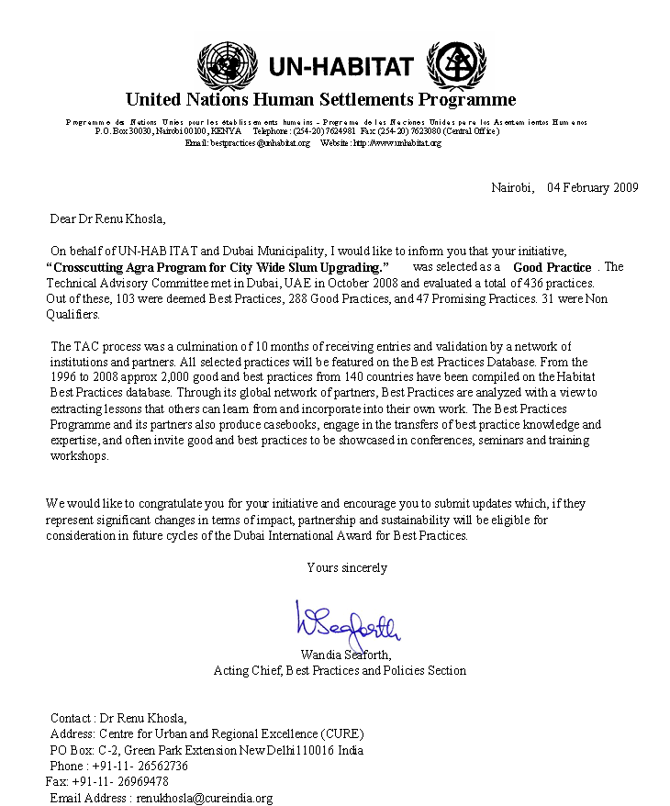
Annexure-2: Private Sector Contribution under CAP/CDS

Sl No | Type of In-Kind Contribution | Who Made Contribution? (Name of Person/Organization) | Date of Contribution/Frequency (# of Hours) | Real/Approximate Dollar or Rupee Value of Contribution
 | Professional Services: Legal Advice, Monitoring of construction, advocacy, documentation, youth development, promoting MHW, painting, story telling workshop, linkage building, guest services, etc… | Mahatam Singh | Regular
 |  | Shahena Khan | 8 months | 4400USD
 |  | Chanda Singh | 2 Days | 48 USD
 |  | Maan singh | 2.5 months | 5305.47USD
 |  | Anil Shukla | 10 months | 3750USD
 |  | Jolly Rohatgi | 20 days | 2500USD
 |  | Saroj Agarwal | 25 days | 8250USD
 | Stage/Theatre programmes | Rangila (Agra Based Theatre Forum) | 5 days | 625USD
 | Cultural promotion | Pushpanjali Trust | 20 days | NA
 | Media (Radio, Television, Press) | Local electronic and print media | Continuous | NA
 | Academic support, research, community radio | University of Agra | 10 days | NA
 | Insurance coverage for the poor | Parivar Suraksha Bima (PSB), HDFC Bank | April 08 onwards | NA
 | Research surveys, design , supervision | London Metropolitan University (LMU) | 55 days | NA
 | Toilet construction | Water Trust | September 07 onwards | 13095USD
 | Toilet construction –design supervision | LMU | Do | NA
 | Space, Facilities to demonstrate | Lady Irwin College, University of Delhi | 1 day | NA
 | Tourist Facilitation centre in Shilpgram | Tourism Guild | Ongoing | The space provided at shilpgram would probably cost at least Rs25000 for others. = 555 USD
 | Development of MHW story | Saroj Agarwal | 3 months | 1200 USDapprox
 | Marketing: Travel Agency sent their customers to the Walk and Hotels display brouchers of MHW | Ventours, SitaTravels, Touraids, Touraids, Clarke Shiraz, Holiday Inn, JayPee Palace | Ongoing | Rs 50,000 each for 5 hotels = Rs. 2,50,000= 5500USD  Being a five star hotels, they charge almost 50,000 for others to display their products but they did not charge any amount from CAP
 | Marketing sources & Printing houses | Local sponsors during Cricket league | 4 days | 119 USD
 | Business Plan Advice? MHW | Tourism Guild, SANKALP, Hotel Holiday Inn | 6 days in the conferences, seminars, training rpogarmmes during the project period | Rs 30,000= 666.USD
 | Physical Office Space in Agra | Agra Municipal corporation | Total of 34 months. | 44575.00 USD
 | Free Health Check Up Camp after Diwali Mela | ESCORTS Heart Institute | 2 days | 2143 USD
 | Teaching literacy to children and others | CSYP Girls from Kachhpura and Yamuna Bridge | January 2008 onwards | 1667USD
 | Book bag orders for livelihood group | Midland Book Agency, New Delhi | 15 days | 285 USD

Annexure-3: Request letter to CA for CDS-II from Agra Municipal Corporation

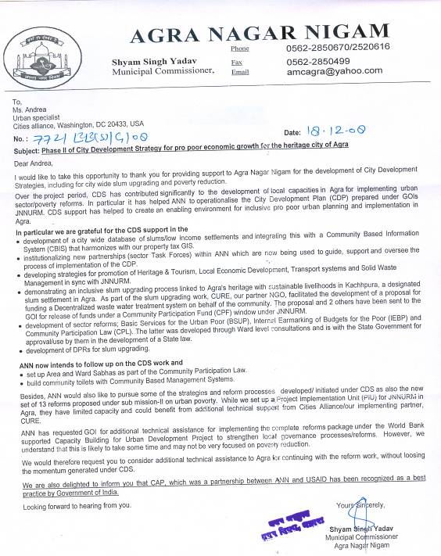
Annexure-4: Capacity Building Proposal

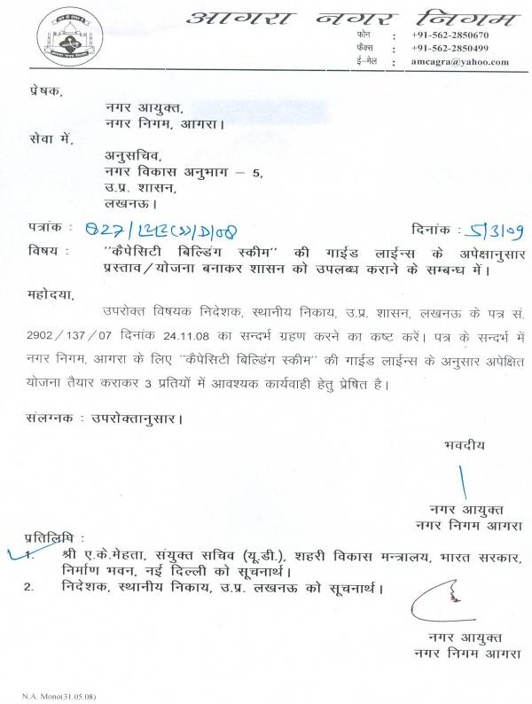

List of Abbreviations

JNNURM : Jawaharlal Nehru National Urban Renewal Mission
CDP : City Development Plan
MDG : Millennium Development Goal
EWS : Economically Weaker Section
LIG : Low Income Group
ULB : Urban Local Body
PIU : Project Implementation Unit
GIS : Geographical Information System
CAP : Crosscutting Agra Programme
USAID : United States Agency for International Development
BSUP : Basic Services for Urban poor
PEARL : Peer Experience and Reflective Learning
MIS : Management Information System
NGO : Non Government Organization
ANN : Agra Nagar Nigam
CBO : Community Based Organization
ER : Elected Representative
CBIS : Community Based Information System
VDO : Voluntary Development organization
TOR : Terms of Reference

- Background:

Agra city is of historic importance, which is amply evident from the numerous historical monuments in and around the city. The heritage of the city is linked with the Mughal dynasty but numerous other rulers also contributed to the rich past of this city. Agra was founded by Sikandar Lodi in the 16th century. It grew into an important power centre under the Delhi Sultan Sikandar Lodi and he shifted his capital from Delhi in 1504. Babar also stayed in Agra for some time and introduced the concept of square Persian-styled gardens.

Taj Mahal, one of the Seven Wonders of the World and a World Heritage Site is in Agra. Besides Taj, the city boasts two World Heritage Sites namely, Fatehpur Sikri and Agra Fort, and innumerable monuments of national /international significance. In addition, the city is a main center of political, economic, commercial and cultural activities in the state of UP because of its central location and rail and road links. This has however, led to an extremely rapid and haphazard growth pattern.

The population of the city as per Census 2001 is 12, 17,534 spread over an area of 141.0 sq km and across 90 Wards. The population of the city has increased rapidly, by over 25% in the past three decades. Infrastructure development has however, failed to keep pace with the population growth. This has had a negative impact on its economy and people.

In November 2005, the Government of India has launched a major urban reform and development initiative called the Jawahar Lal National Urban Renewal Mission (JNNURM). The JNNURM aims to provide an incentive to large urban areas to undertake institutional, structural and fiscal changes necessary for improved service delivery systems that are sustainable, address poverty and enhance local economic performance.

The Mission will make available resources to 63 large cities, for implementing these reforms on the basis of a city development plan (CDP) prepared through a consultative process, linked to a city-wide vision and strategy for implementation. A key object of JNNURM aims at scaling up delivery of civic amenities with emphasis on universal access to urban poor.

The JNNURM is broken up into two sub-missions: one on Urban Infrastructure and Development (led by the Ministry of Urban Development) and the other on Basic Services to the Urban Poor (led by the Ministry of Urban Employment and Poverty Alleviation). The thrust of the sub-Mission on Basic Service for Urban Poor is on programs like Slum Improvement and Rehabilitation, Sites and Services, Environmental Improvement, Night Shelters, Community Toilets and Housing at affordable prices for EWS and LIG categories etc. Once implemented, these reforms will ensure the following outcomes:

- All urban poor, in particular slum dwellers, will gain access to basic municipal services such as water supply, toilets, waste water drainage, solid waste management, power, roads, transport, etc.

- All urban poor settlements will be integrated and mainstreamed with municipal supply networks resulting in sustainable improvements in the quality of life of the urban poor.
The Bigger Mandate

Government of India is committed to reducing by half the number of people living in slums and urban poverty by 2011 and to achievement of the Millennium Development Goals (MDG) set down by the UNHABITAT.

A key objective of the government is to guarantee that all citizens equally benefit from national economic growth.

Poverty reduction and urban development that benefits all is also a key goal under JNNURM.
- Urban poor communities will have better access to legal and affordable housing with in-house basic services that will allow them to live as legitimate citizens.

- Urban poor communities will have improved access to social services such as education, health and other social programmes of the government. This will ensure better education, improved health and access to sustainable livelihoods which in turn would help reduce poverty.

- Urban poor will be able to voice their demands/grievances related to basic service provision. Their participation in political processes and city governance will also be enhanced.

- Reform Initiative:
To get assistance under this scheme, the cities are required to carry out reforms in the following areas:

- Internal earmarking within local body budgets for basic services to the urban poor- eventually developing a Basic Services to the Urban Poor Fund.

- Implementation of 7-Point Charter, i.e. provision of basic services to urban poor including security of tenure at affordable prices, improved housing, water supply, sanitation and ensuring convergent delivery of existing universal services for education, health and social security within the Mission Period (2005-12) according to agreed timelines.

- Earmarking at least 20-25% of developed land in all housing projects (both public and private agencies) for EWS/LIG category with system cross- subsidization.

These three reforms have direct or indirect linkages of other reforms to be carried out by state and Urban Local bodies under JNNURM.

Reform | Linkage
Community Participation Law | Community mobilization processes in slum areas for planning and service delivery will help to develop local level leadership at the ward and Area Sabha levels.
Modern municipal accounting systems | The DEA system will help to track expenditure on service provision and housing to slum areas.
User costs for full cost recovery | Lifeline tariff slabs for the poor will need to be ensured in setting up of tariff systems. Provisioning of metered services in slum areas will improve cost recovery and reduce transmission losses.
Property tax | Inclusion of poor (resettled or provided housing/pattas) into property tax systems.
Property titling | Inclusion of poor with houses/pattas in property titling.
Public Disclosure Law | Information dissemination to various stakeholders on progress of projects, reforms and financial management of ULBs.
E-Governance systems | All slum information may be integrated with the computerization of poverty tax maps and MIS systems. E-Governance programmes will be targeted to slum areas to improve effectiveness of birth and death registration, complaint redressal, payment of user charges, etc.

- Need For Capacity Building:

These reforms will significantly improve the quality of lives of citizens including slum dwellers by providing them access to improved housing and quality services. It will also indirectly result in increased incomes and a reduction in the disease burden of households. The success of these reforms will depend on the ability of local governments to engage people in the process of planning and implementation.

Municipal Corporation of Agra is implementing JNNURM and has already committed itself to carry out these reforms at the ULB level. Over a period of time the corporation has taken several reform initiatives though there is great need of capacities required at ULB level for further reform-oriented steps in order to meet not only the targeted development objectives but also urgently take measures to enhance efficiencies in urban service deliveries.

While several reform initiatives are being taken up at the sate level, capacities are limited at the ULB level to implement the reforms in order to meet the development target and enhance efficiencies in urban service deliveries for the poor. There is need for huge capacity building at the City level, within the ANN and other concerned local agencies, elected representatives and civil society. The Municipal Corporation Agra is seeking support from Government of India for capacity building of municipal staff.

The Agra Municipal Corporation has set up a Project Implementation Unit (PIU) with staff hired directly to implement JNNURM. The purpose of choosing this model over the outsourcing model was to ensure sustainability of initiatives and creation of in-house capacity. However, much of the staff in the PIU is still fresh and needs greater understanding of their roles and responsibilities to become effective.

Agra has also been implementing the Crosscutting Agra Programme (CAP) in slum upgrading, poverty reduction and reform implementation with the support of USAID-FIRE D (III), Cities Alliance and the Centre for Urban and Regional Excellence. CAP has been recognised as a Good Practice for 2008 under the UN Habitat Dubai Municipal Awards. The present capacity building programme will continue to use the support of the above agencies in implementation. It will also complement the second phase of CAP under Cities Alliance for implementing a slum upgrading plan for city wide development.

4. Target Groups:
The objective of the capacity building program will be to:

- Strengthen capacities of local elected representatives and Municipal Corporation officials including PIU staff, to plan and implement the BSUP reforms agreed upon under JNNURM.

- Target user groups and the civil society of Agra to work in partnership with a reforming local government and to contribute to the process of planning for slum upgrading and city development.

- Improve the efficiency and effectiveness of local governance processes to address the needs of urban poor communities in the city in a sustainable and convergent manner.

Under the capacity building programme the following activities will be undertaken:

- Workshops, seminars and motivation programs for elected representatives, city officials including street bureaucrats (area functionaries/junior engineers etc) and PIU officials to create better awareness of recent developments /good practices in other cities pertaining to implementation of JNNURM reforms and projects.

- Exchange visits of municipal officials/PIU and regional consultants.
- Twinning with other cities through the PEARL network with a view to learn and share lessons through inter-city consultations.

- Creating a platform for convergence with various sector departments for the implementation of the 7 point charter.

- Hands on learning through development of projects using participatory processes.

The training will not be generic and in isolation but will be linked with the projects initiated and reforms agreed by the state and ULB under the JNNURM. It will be demand driven based on a preliminary scoping exercise to understand capacity building gaps.

Project specific workshops will build skills of officials engaged with the projects initiated under JNNURM. Training will also be aimed at building convergence with other actors and partners such as health and education for a concerted effort at meeting the objectives of the BSUP. While the Health functionaries may be trained on the technologies of solid waste management, engineers will need orientation to public health engineering and project development concepts and operation and maintenance issues, education officials will be oriented to the need for health and hygiene behaviour change.

The contents of the capacity building program will be developed through a stakeholder analysis of learning needs. Some of the contents of the capacity building will include:

- New and emerging trends in urban policy and reform, in particular for urban poor communities.
- Legislative framework within which ULBs function and the new and improved framework envisaged.
- Deepening managerial, technical and analytical skills for improving urban administration such as use of an MIS on a spatial GIS based platform.
- Knowledge of new/ innovative systems of public management /pro poor governance.
- Financial management and accounting reforms, resource mobilization, water and sanitation service delivery improvements, private sector partnerships etc.

- Implementation Strategy:

Agra Municipal Corporation is divided into 90 municipal wards. The capacity building progarmme for Elected Representatives will be completed in three groups of 30 ward councilors each for ward level bottom up planning and other project development activities. Ward level workshops will include the local municipal staffs (executive engineers, JEs, AEs and public health engineers), the PIU team, local communities and civil society /NGO representatives. The progarmme also intends to associate local media persons and other stakeholders of the city to ensure a broad based impact.

The target of the capacity building programs is depicted below graphically:
Capacity Building Scheme for Agra Nagar Nigam (ANN)

Media

Municipal staffs
PIU members
Finance and Engineering officers
Slum level field officers
Elected Representatives (90)

Academia
Civil Society
NGOs & CBOs

Ward level planning workshops will also be done in the same manner in three phases wherein the first round will focus on identifying the issues and concerns of the community and to identify the projects. In the second workshop the draft pr the project with designs will be shared with the community and their concerns will be incorporated and the ward level planning document will be finalized in third phase.

- Budget Proposed:
Sl No. | Activity | Purpose | Number  (2009-12) | Amount in Rs.
 | Advocacy Workshops | Two day Orientation workshops for elected representatives (90) | 12 workshops per year (four workshops for three group of 30 wards each) | Rs.30,000 per Workshop  Rs. 3,60,000 per year
 | Reform workshops/training program for JNNURM components | Selected Reform Specific Workshops and guide in formulating action plans and milestones for achieving the reform outcomes | Four workshops/training per year | Rs.25,000 per Workshop  Rs. 1,00,000 per year
 | Ward level bottom up planning workshops | To get ward level plan to be incorporated in project developed under BSUP and set up ward sabha, area sabha and committees | 12 workshops per year (four workshops for three group of 30 wards each) | Rs.30,000 per Workshop  Rs. 3,60,000 per year
 | Project Development workshops | Workshops for ANN to initiate proposals under BSUP | Six workshops per year | Rs. 25,000 per workshop  Rs. 1,50,000 per year
 | Project Management Workshops | Workshops on supervising and management of projects. | Six workshops per year | Rs. 25,000 per workshop  Rs. 1,50,000 per year
 | Workshop on deepening managerial, technical and analytical skills for improving municipal administration | To bring professionalism in working model of ANN. | Four workshops per year | Rs. 25000 per workshop  Rs. 1,00 ,000 per year
 | Workshop on process documentation and reporting. | To proper record the process and enhanced skills for reporting. | Four workshops per year | Rs. 25000 per workshop  Rs. 1,00,000 per year
 | Capacity building training for municipal sanitation staffs and ERs on National Urban sanitation policy/Right to Information and other government programmes. | Training on policy framework and strategy for implementation for the scheme. | Four workshops per year | Rs. 50000 per workshop  Rs. 2,00,000 per year
 | Strengthening of PIU at ANN | Provide information to policy makers and practitioners to take up urban innovations and develop an effective and efficient Management Information System to monitor achievements of JNNURM and Reforms | Information centre/ Resource centre on urban management best practices through (a)Web page on project, (b) newsletter,  (c)project specific dissemination material  (d) heritage cell | Rs. 15,00,000 Lakh per year  Rs. 15,00,000 per year
 | Training Programme on development of proposal for applied research and development programmes related to water, sanitation, SWM etc. | To be able to develop proposals for applied research for addition support to the corporation | Six workshops per year | Rs 25000 per workshop  Rs 1,50,000 per year
 | Training on setting up of Community Based Information System (CBIS) in Nagar Nigam by using GIS. | Information base of slums, services and other infrastructure recorded in CBIS. | Four workshops per year | Rs 25000 per workshop  Rs 1,00,000 per year
 | Training programme for Setting up of MIS & Grievance redresal cell | Setting up of MIS | Four workshops per year | Rs 25000 per workshop  Rs 1,00,000 per year
 | Seminars/conference on heritage conservation and sanitation, economic development etc |  | Four workshops per year | Rs.50,000 per Workshop  Rs. 2,00,000 per year
 | City consultation on municipal service delivery and planning with civil society, NGOs & VDOs working in the city | To engage them in planning and development process of the city. | Four workshops per year | Rs 30,000 per workshop  Rs 1,20,000 per year
 | District level media orientation and advocacy workshop | To orient media (Electronic & Print) on government schemes and status of implementation. | Six workshops per year | Rs 30,000 per workshop  Rs 1,80,000 per year
 | Strengthening of Heritage cell in ANN | Provide information on heritage and tourism related materials, Specified TORs, Posters, leaflets, monument information. | Information centre , resource centre on tourism | Rs 1,00,000 per year
 | Exposure visit of municipal officials to best practice cities | To visit best practices and learn from them | Four visits per year | Rs.3,00,000 per exposure trip  Rs. 12,00,000 per year
 | Publishing bimonthly newsletter of ANN | To document the initiatives taken up by ANN | Two in a year | Rs 75,000 per newsletter  Rs 1,50,000 per year
Total Per year |  |  |  | 53,20,000
Grand Total for three years (2009-12) |  |  |  | 1,59,60,000

Annex 5: CAP Outcomes
 | Household | Community |  | City
- Outreach: 2700 HHs, 9 slum clusters, 2 Wards.
- Roll out: From 5 to 9 cluster and additional Wards
- Reduction in open defecation through access to toilets | - 200 HH get toilets (1200 people use home toilets). |  | - 200 girls and boys have access to school toilets.  In the works:  - Community toilet planned with ANN funds to benefit additional 200 HHs.  - School toilet in Yamuna Bridge settlement to benefit an additional 400 children
- Slums upgraded |  |  | - 2, Improved drains and roads benefit 200 HHs directly with visibly clean environments  - DEWAT to benefit 800 HHs approved
- Environmental improvements |  |  | - Door-to-door private waste collection services and regular waste disposal.
- Incomes improve sustainably with tourism linked livelihood (MHW and Bag enterprise) | - Women and young people (50) improve incomes.  - MHW business plan developed  - Bag enterprise reaches sustainable levels
- Savings and debt reduction | - Increased HH savings, debt swaps through SHG participation; SHGs fully self reliant and apolitical.
- Improved employability | - Youth groups improve personal /employment assets, participate in civil improvement works, engage with local government agencies.  (Development Asset Profile show significant increases in assets among youth (boys and girls)
- Communities organize for local action |  |  | - Women, youth communities get organized, become aware and capable of negotiating for entitlements.
- Increased civic engagement |  |  |  | Slum residents and youth understand civic responsibility, contribute to city development planning.
- Strengthened civil society |  |  |  | Civil society groups with better skills.
- Private sector partnership |  |  |  | Become socially responsible/contribute to livelihood promotion.
- Local capacity for slum upgrading, reform, governance |  |  |  | Strengthened institutions and partnerships.
- Catalyse urban sector reform |  |  |  | Implementation starts

Annexure 6: Letter to UNESCO for IHCN membership
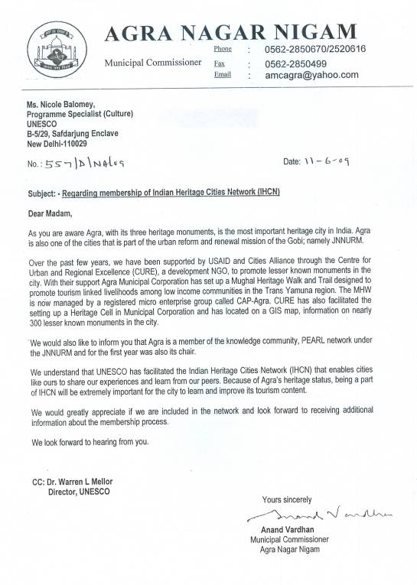

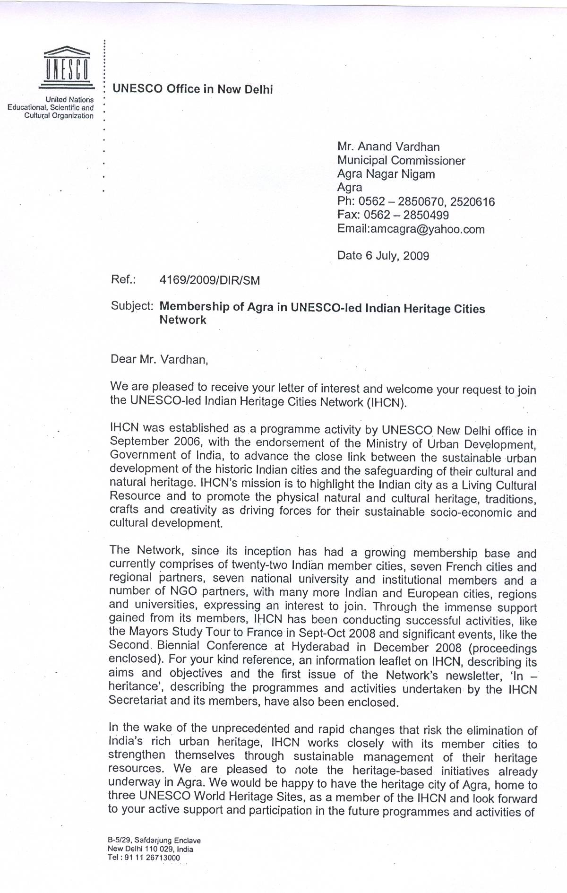

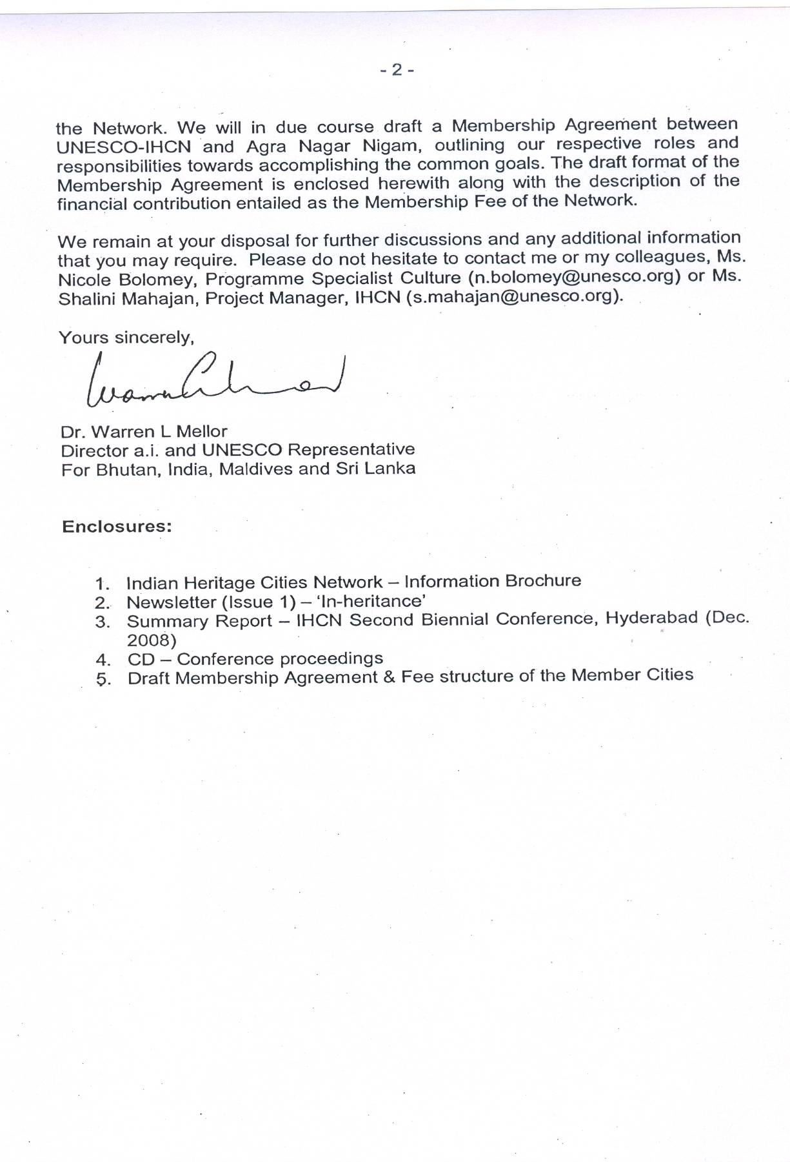

Country-specific proposals typically originate from local authorities, but must be sponsored by at least one member of the Cities Alliance (see Cities Alliance Charter, Section D.14).
Notified slums are those which fall in the municipal area and are recognized for service delivery while non-notified slums those that have come up after the last listing and remain unacknowledged for service delivery
DUDA is responsible for development of notified slums and ANN for the non-notified slums
Consultations will be organized in 85 Wards having slums only. As data for SUS was collected in 2006 it is expected that the number of slums will have increased and possibly covering all Wards over the project period.
Estimates from SUS, 2006
ANN has set up a Project Implementation Unit (PIU), comprising of five specialized officers in IT, Public health, social development, Environment and HRD. The PIU experts reports to the Executive Engineers/Nodal Officer for JNNURM and discusses day today issues proactively.

