08

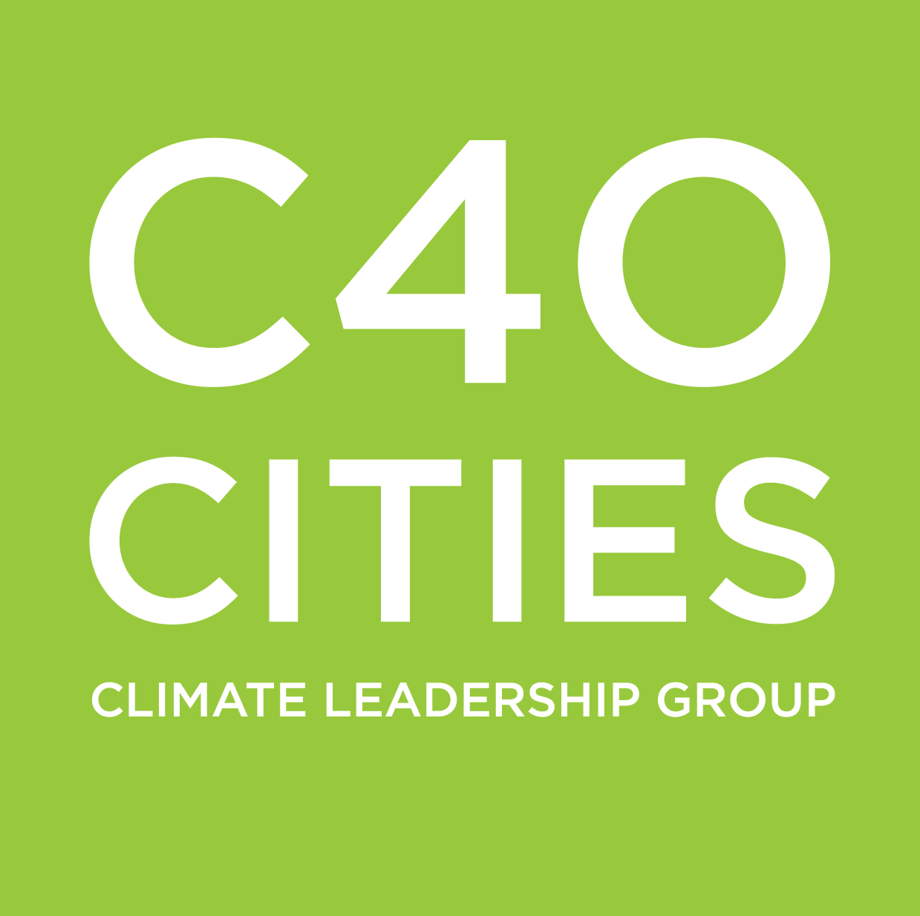
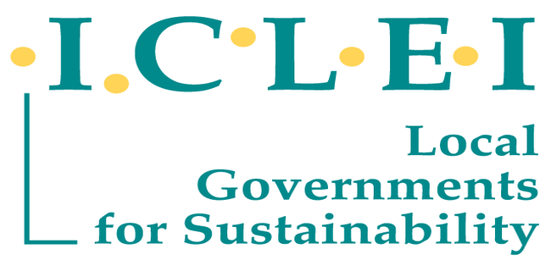

2018
Cities and Climate Change Science Conference
Co-sponsored by IPCC

Host City selection process
Request for Proposals

Closing Date: 23:00 UTC on 31 January 2017.
Submission: Electronically in PDF format to citiesipcc@c40.org

Table of Contents

About #CitiesIPCC 3
The 2018 Cities and Climate Change Science Conference 4
Host City Selection Process 7
Responsibilities of #CitiesIPCC and the host city 7
Bid submission 9
Reasons for hosting the 2018 Cities and Climate Change Science Conference 9
Meeting the host city obligations 10

Fundraising Strategy 15

Budget 15
Submission Format and Method, and Decision-Making 16

About #CitiesIPCC

At the 43rd session of the Intergovernmental Panel on Climate Change (IPCC) in Nairobi from 11-13 April 2016, the Panel agreed (Decision (IPCC/XLIII-6):

- To give cities a special focus in all scoping processes of the sixth assessment cycle (AR6), i.e. in the next main assessment report (due by 2022), and the three special reports on 1.5 degree, Oceans and Cryosphere, Land-Use related themes, to be delivered between 2018 and 2019.
- To include a Special Report on Climate Change and Cities in the seventh assessment cycle (AR7)
- “To consider working with academia, urban practitioners, and relevant scientific bodies and agencies, to organize an international scientific conference on climate change and cities early in the AR6 cycle, in order to stimulate scientific reports and peer reviewed publications on this subject”.

These are very positive developments in light of the #CitiesIPCC campaign led by C40 and ICLEI in March-April 2016, and supported by 20 cities and 25 organizations.

This decision was celebrated by urban stakeholders because:

- After the political recognition at COP21, cities are gaining increased recognition amongst the international scientific climate community, which provides the evidence base for the UNFCCC negotiations. So the Paris momentum is strengthened by this decision
- It provides opportunities to dramatically increase the scientific evidence on cities and climate change, in order to enable better climate policy-making at local level
- With the Special Report decided seven years in advance, it provides adequate time for cities and networks to work with National governments and universities on new, well-funded research programs on cities and climate change in order to generate the literature that will provide the basis for this assessment. The International Scientific Conference on Cities and Climate Change is an important international milestone beginning this process.

A joint proposal from C40, Cities Alliance, ICLEI, Future Earth, SDSN, UCLG, UN-Habitat, UN Environment and WCRP to co-organize an international scientific conference on cities and climate change co-sponsored by IPCC was subsequently submitted to the IPCC Bureau in August 2016, and approved by the IPCC 44th Plenary Session in Bangkok on October 20, 2016.

For the purposes of this call for proposals, “#CitiesIPCC” includes the following as co-organizers of the International Scientific Conference on Cities and Climate Change:
- C40
- Cities Alliance
- Future Earth
- ICLEI
- IPCC
- SDSN
- UCLG
- UN-Habitat
- UN Environment
- WCRP

The 2018 Cities and Climate Change Science Conference

Background

The Cities and Climate Change Science Conference is planned for the first week of March 2018 and will bring together representatives from the academia, scientific bodies and agencies; concerned member states of the United Nations; city and regional governments; and urban and climate change practitioners. The main aim is to stimulate scientific research (including peer review publications) around cities and climate change to provide input to be assessed by the three Working Group Reports and three Special Reports (SRs) of the sixth assessment cycle (AR6) and to establish the foundation for the SR on cities and climate change that will be undertaken during the seventh assessment cycle (AR7).

Objectives
The overall objectives of the 2018 international Scientific Conference on Cities and Climate Change are to: identify key research and knowledge gaps with regard to cities and climate change; inspire global and regional research that will lead to peer-reviewed publications and scientific reports; and stimulate research in Cities and Climate Change over the AR6 cycle.

The specific aims of the conference are to:
- Take stock of the scientific literature, data and other sources of knowledge that have emerged around cities and climate change since the close of AR5 (i.e. March-October 2013) and build on ongoing work as part of the AR6 cycle.
- Identify key gaps in the scientific literature, in keeping with the emphasis that arises from the scoping of the AR6 and its three SRs and international, regional and national policy and implementation imperatives that emerge from COP21, the Sustainable Development Goals (SDGs) and the New Urban Agenda.
- Identify key research and knowledge gaps, with the aim of stimulating new research, the findings of which to be assessed in AR7’s Special Report on Cities and Climate Change.
- Develop novel assessment frameworks that take into account the systemic linkages, synergies and trade-offs between urban systems and climate change, especially action at the local scale.
- Identify the research gaps in terms of policy and implementation in order to facilitate the consideration of such areas in anticipation of the Special Report on Cities and Climate Change.
- Bring together key urban and climate change stakeholders to identify priorities for scientific and policy research during the AR6 cycle and to stimulate the co-design and co-production of actionable knowledge.
- Building on established United Nations, member state and research network initiatives, help define appropriate global, regional and local monitoring systems and data architectures to facilitate scientific research and to help inform evidence-based policy development on climate change and cities.
- Establish a partnership-based platform to systematically accumulate, assess, analyze and disseminate information on science-policy-practice linkages that enable an upscaling and mainstreaming of urban climate actions at all scales.

Outcomes
The expected outcomes of the conference include:
- A report of the meeting to be prepared under the guidance of the Scientific Steering Committee with inputs from conference participants. This report will provide a summary of the conference discussions. These proceedings will:
• include a full list of participants;
• indicate when and by whom they were prepared;
• indicate whether and by whom they were reviewed prior to publication;
• specify all sources of funding and other support; and
• prominently display the following disclaimer at the beginning of the document:
“IPCC co-sponsorship does not imply IPCC endorsement or approval of these proceedings or any recommendations or conclusions contained herein. Neither the papers presented at the Workshop nor the report of its proceedings have been subject to IPCC review”
- Scientific Proceedings and commissioned background papers to inform discussions at the conference.
- A paper on key short to mid-term research themes during the AR6 cycle and opportunities to support these.
- A proposal on appropriate global, regional and local monitoring and data architecture to assist in scientific research and inform evidence-based policy development on climate change and cities.
- A proposal to build a partnership-based platform to systematically accumulate, assess, analyze and disseminate information that enables upscaling and mainstreaming of urban climate actions at all scales.

Partner Organisations

To make maximum progress on these objectives, the conference is co-organized by three main constituencies: the research community, represented by Future Earth and WCRP; the global urban community, represented by C40, ICLEI, UCLG Cities Alliance, and SDSN; and the intergovernmental system represented by UN Environment, UN-Habitat; and IPCC. This will create synergies with the three agreed intergovernmental processes: the SDGs, Sendai Framework for Disaster Risk Reduction and Habitat III, and will facilitate engagement with Future Earth’s emerging research agenda on cities and sustainable urbanization currently being built around a growing international network of over 50,000 researchers.

The conference will include contributions from a set of five primary partners:

- IPCC through its co-chairing and sponsorship
- UN-Habitat and UN Environment (via Cities Alliance), co-organizers, representing the United Nations system
- Future Earth, a co-organizer, representing academia and the scientific community, with a specific focus on cities and transdisciplinary approaches, together with WCRP as a co-organizer representing the climate research community;
- Cities Alliance, C40 Cities Climate Leadership Group, ICLEI, UCLG and SDSN, co-organizers, representing city and regional governments, the enterprise sector, and a range of member states;
- A city/national government to serve as host (to be confirmed after an open call to be coordinated by the Global Task Force including C40, ICLEI and UCLG);

Timing and Duration
The conference is expected to be held during the first week of March 2018, synchronised with other ongoing international conferences and IPCC events and consultations around complimentary themes. The conference is expected to last three days, with an opening plenary; and a closing plenary on the evening of the third day.

Conference Participants

Expected participants’ constituencies: representatives from academia, scientific bodies and agencies; concerned member states of the United Nations; city and regional governments; and urban and climate change practitioners.

The conference is expected to draw between 300 to 1000 participants from across the world, of which over a third will be from developing countries. Developing country participants who do not have institutional support for travel, would be provided travel funding from the IPCC Trust Fund (with a maximum of 50 trips) and other sponsors.

Scientific Steering Committee, Organising Committee and Management arrangements

A Scientific Steering Committee (SSC) will manage the conference and its proceedings. SSC members will be drawn from partner organisations and key stakeholder groups, based on high scientific standards, and will strive to maintain a balance across regions, gender and scientific disciplines and themes.
The conference will be administered by an Organising Committee, including representatives from the IPCC Secretariat and Working Group Technical Support Units (as appropriate), and the Head of the local Conference Secretariat and representatives from the partners organizations.

Timeline

An indicative timeline for the conference is as follows:
- Launch of the call for host city (November 2016 at UNFCCC COP22)
- Selection of conference location (February 2017).
- Announcement of the Conference, initiation of Organising Committee and local Secretariat and launch of website (February 2017).
- First meeting of the Scientific Committee. Commissioning of preparatory papers (March 2017).
- Call for nomination of participants and initiation of outreach and advocacy activities (June 2017).
- Second meeting of the Scientific Committee and selection of Participants (August 2017).
- 2018 Cities and Climate Change Science Conference (first week of March 2018).
- Third meeting of the Scientific Committee and clearance of Proceedings for publication (June 2018).
- Publication of proceedings (September 2018).

Host City Selection Process

The host city of the 2018 Cities and Climate Change Science Conference will be selected through an open call for proposals launched on November 10, 2016 during COP22, and closing on January 31, 2017. The selection process will be managed by the consortium of co-organizers of the Conference, below identified as “#CitiesIPCC”.

Eligibility

The host shall meet the following eligibility criteria:
- a city government, with support from their national government
- a city recognized for their climate leadership and engaged with international partners and initiatives
- a city experiencing a high level of climate risk who would benefit from hosting the conference through increased local awareness of climate change and improved prospects of support for climate action.
- a significant hub for academic research at national, regional or global level
- a city from the Global South will be prioritized

Additionally, the host city must:
- have capacity to host an international conference of 300-1000 persons, and provide a good range of logistical options
- provide co-funding and dedicate staff for the whole process from February 2017 through March 2018
- demonstrate documented support from all (or several) levels of government in the country, institutions and/or individuals.

Responsibilities of #CitiesIPCC and the host city

The host city will be responsible for delivering the majority of the logistics of the Conference, in particular, event production, hospitality and local media.

#CitiesIPCC will be responsible for managing the engagement with other cities, scientific content, speakers, other dignitaries and international media; and this will be done in collaboration with the host city as appropriate. #CitiesIPCC will also provide external advice to the host city, have approval rights on all elements of the Conference, and where necessary provide additional support. The ultimate success of the Conference is dependent on a City Organising Committee that has the resource, experience and expertise to co-ordinate an international conference in its totality, on time and to budget.

The host city’s financial responsibility for hosting the Conference, is detailed below.

The host city will set up a Conference Organising Committee (or an agreed upon equivalent name), comprised of representatives from both the host city and #CitiesIPCC. The Conference Organising Committee (COC) will manage the planning and organisation of the Conference and ensure effective and frequent collaboration between #CitiesIPCC and the host city. This Committee will provide transparency to ensure that both the host city and #CitiesIPCC meet their obligations under the host city contract and that the Conference planning progresses according to the agreed timelines. This will be chaired by a senior official of the host city.

The key responsibilities are shown in the table below.

Area of responsibility | Host city | #CitiesIPCC
Event management and contracting | Responsible for contracting and managing the Professional Conference Organiser (PCO). | Approval of PCO contract, third-party supplier contracts and changes to scope of work
Branding – look and feel | Design and production of: event dressing, marketing materials, conference materials and registration materials in line with Conference branding guidelines | Production of branding guidelines and approval of all materials
Media and PR | Local media & PR including a media strategy | International media & PR and approval of media strategy
Conference programming | Identification of Master of Ceremonies to host the Conference | Content (including networking), structure & speakers
Electronic pre-registration | Agree to the structure and content for the online registration tool  Update plans following regular registration updates from #CitiesIPCC | Develop an online registration tool  Manage pre-registration – relaying information to host city for on-site registration
On-site registration and accreditation | Provide on-site staffing and technical facilities for on-site registration and accreditation  Print of all accreditations and provide material to fulfill all onsite | Manage on-site registration process and hire of a registration manager to oversee the process
Hotel | Secure the necessary hotel room nights for all Conference attendees / organisers /partners.  Ensure specific requests fed in from #CitiesIPCC are accounted for | Confirm hotel requirements via online registration and relay to host city.  Pay for hotel rooms for its staff
Venue | Book, manage and pay for venue including all spaces/rooms necessary for the Conference  Host city will book venue including all spaces/rooms necessary for the Conference agenda with support personnel and equipment as necessary. As much as possible, the venue should meet energy- and environmental friendly criteria. | Approve venue spaces/rooms and layout
International travel | Provide travel agent services for all participants | Book and pay for flights for its staff.
City Transport | Book, manage and pay for all transport needs within the city, including to and from airport for all attendees, and favouring public, green and low-emission transportation. | Relay transport needs of attendees
Security | Provide all security requirements | Approve security plan
Welcome package | Provide Welcome Packages to participants (as much as possible made from local entreprises) | Approve content of Welcome Packages
Visa support | Support participants in obtaining visas | Advise visa needs of attendees
Hospitality | Provide food and beverages at the Conference and associated receptions (local food and beverages with environmental friendly packaging to be favoured) | Approve plans
Cultural programming and tours/visits | Organise and run cultural programming and tours/visits | Approve plans and provide advise
Conference website and app | Relay information to #CitiesIPCC for the Conference website and app including relevant elements noted above. | Responsible for development, maintenance and content
Budget management | Budget management with regular updates to #CitiesIPCC | Determine budget priorities, approve plans and progress
Video recording & editing | Video recording of all plenary and breakout / working sessions, as well as editing of the footage for wrap videos  Live streaming of the event on the Conference web pages | Approve plans
Community mobilization | Mobilize local, national (city and country host) community in coordination efforts done by Cities IPCC to mobilize global community | Key role to mobilize globally
Exhibition (optional) | Plan an exhibition that focuses on the sustainable development successes of the Host City | Approve plans

Bid submission

Cities interested in hosting the International Conference on Cities and Climate Change Science should provide information on:

1. Reasons for hosting the Conference
2. Meeting host city obligations
3. Fundraising strategy
4. Budget, including contingencies

Reasons for hosting the International Scientific Conference on Cities and Climate Change

Prospective host cities are asked to set out their rationale as to why they are best placed to host the 2018 Cities and Climate Change Science Conference. #CitiesIPCC requests that the following information is provided:

- Information on the city’s response to climate variability and climate change at the local level (both on mitigation and adaptation) and engagement in international city networks and initiatives, such as the Compact of Mayors, Global Covenant of Mayors for Climate and Energy, or similar platforms.

- A short description of the benefits of hosting the Conference in your city.

- Demonstration of the commitment of the city Government, and in particular the Mayor. We would ask you to attach to your submission a letter of support from the Mayor, with confirmation that the Mayor submitting the bid will still be in office at the proposed time of the Conference.

- Letter of support by the National Government, ideally the IPCC focal point of the country, and other levels of governments (regional, provincial, etc).

- Demonstration of experience of hosting conferences/events within the city of this scale including any supporting documentation and case studies.

- Demonstration of relevant experience of the city government and the city government staff in hosting similar conferences/events.

Meeting host city obligations

Event management and contracting

The host city will be required to hire a Professional Conference Organiser (PCO) that is familiar with the unique demands of hosting an international conference and capable of delivering an event of high standards from an organisational point of view as well as technical. Before a professional event and audio-visual production team is hired, #CitiesIPCC would expect that a competitive selection process is undertaken for this role, with a minimum of 3 quotes provided. #CitiesIPCC will support the host city in drafting the specification for the PCO work and would have the right of approval of the specification. #CitiesIPCC and the host city will jointly select the PCO. The proposed contract between the host city and the PCO will need to be approved by #CitiesIPCC before a PCO is appointed. There should be an emphasis on delivering the Conference using the most sustainable practices possible.

The PCO is likely to appoint several sub-contractors to deliver various aspect of the work required. The PCO should secure a minimum of 3 quotes for each element to ensure that value-for-money is maintained. #CitiesIPCC would have approval over the Request for Quotes, appointments and contractual terms.

The PCO will then work with the host city and #CitiesIPCC, which will have final say on all strategic decision-making related to the Conference, as well as the sets and audio-visual decisions.

Please provide information on the mechanisms/procedures for appointing PCOs within your city and give details of PCOs that you have worked with recently and the events that they have been responsible for delivering.

Venue

The host city will book and procure an appropriate venue for the Conference. This will contain the required facilities as specified in this document, including:

- Main plenary area capable of holding up to 1000 participants
- A minimum of 5 breakout rooms each for up to 150 participants
- Additional rooms for small business meetings for up to 15 participants
- Rooms for bilateral meetings (at least 5 rooms)
- Office for the #CitiesIPCC team
- Meeting room for #CitiesIPCC Steering Group for up to 30 participants
- Exhibition space (potential additional option)
- Dining rooms capable of holding up to 1000 delegates (breakfast and lunch)
- Media suite capable of meeting the demands of international media
- Press Conference room
- Delegate WIFI to meet suitable connectivity standards
- Staffing and equipment as necessary
- Technical support for all technology services
- Registration area
- Business / networking lounge for attendees with printers and charging stations
- Conference centre with an environmental or sustainability strategy will be favoured.

Please provide details of the proposed venue for the Conference including details on the available facilities, including capacities and availability for the dates you propose. A venue that operates a strong and internationally recognised low carbon/sustainability policy is strongly preferred.

Hotel

The host city will: identify, negotiate the price of, and arrange for a hotel block/s for participants attending the Conference in a diverse range of hotels across the city.

Please provide details of the proposed hotels including capacities and availability during the dates propose for the Conference, facilities available, distance from proposed Conference venue, and room rates at the proposed time of year. There should be high-standard WIFI and printing services at any accommodation options. Hotels that operate a strong and internationally recognised low carbon/sustainability policy are strongly preferred.

Branding – look and feel

The host city will design all branding including signage and dressing for the Conference. #CitiesIPCC will provide input on design and content and will have final approval rights on the design and content of all branding. The host city will be responsible for the cost of production of the Conference branding.

The host city will work with #CitiesIPCC to develop marketing materials and collateral for Conference attendees. This will include all credential badges, lanyards and other accreditation materials related to the Conference as well as all handouts. The host city is responsible for the design and production of these materials. #CitiesIPCC will provide input on design and content and will have final approval rights on the design and content of all such materials.

#CitiesIPCC strongly recommends the use of recycled materials or screens displaying content instead of paper take-aways where possible.

Please provide details of the Conference branding and marketing materials you propose for the Conference, these can be both within the venue/s and within the host city itself.

Media & PR

#CitiesIPCC and the host city will work collaboratively to develop and execute a comprehensive media plan for the Conference which #CitiesIPCC will have final approval rights on.

#CitiesIPCC will be responsible for all media and communication outside the national borders of the host city. The host city shall have responsibility for all media and communications within the national borders of that country. All media releases must be approved in advance by the #CitiesIPCC communications team.

Please provide details as to how you will maximise the media and PR coverage within your national territory and how you will support #CitiesIPCC in promoting the event to a global audience.

Visa support

The host city will provide visa letters to participants requesting support obtaining a visa.

Please confirm that your city will be able to support participants with their visa process.

City transport

The host city will arrange airport pickup for all the Conference participants and outside speakers. This does not need to be an individual car and could be a shuttle or van service – depending on host city preference.

The host city will provide transportation between all event venues, meals, receptions, site visits (if offered). Public and green transports are preferred.

Please provide details of how you will provide airport and other transport services offered during the Conference and how the low-carbon footprint of the services will be minimised.

Security

The host city will work collaboratively with #CitiesIPCC and other participants to coordinate all security needs for the event. This will include providing appropriate security at the event itself (and any additional receptions and dinners), and providing full security walk-throughs in advance for any participant requesting this.

Please confirm your proposed broad security arrangements for the Conference. It is accepted that these will change as the planning for the Conference develops.

Content

#CitiesIPCC will be solely responsible for the content of the event. However, the host city will identify a Master of Ceremonies, with #CitiesIPCC having the final decision on the selection of a Master of Ceremonies. This will be paid for by the host city.

Please provide any ideas of suitable local Master of Ceremonies, including availability and track record in environmental/ sustainability causes.

Welcome package

The host City will provide a Welcome Package for all attending participants. Traditionally, the host city provides a very small welcome package for each of the attendees, and another slightly larger gift or welcome package for VIPs. #CitiesIPCC will work closely with the host city and advise on best practice.

Please provide proposed ideas for welcome packages for attendees and VIPs. Proposals that fit with the low carbon focus and local development of the event are strongly advised.

Cultural programming and tours/visits

The host city will arrange all site visits for participants attending the Conference (and other attendees as agreed upon with #CitiesIPCC) to showcase sustainable development wins that are best toured in person. Site visits should not compete with the Conference agenda, but rather take place before or after the Conference for those participants that choose to stay on. The host city is responsible for all logistics related to these site visits.

If the host city wishes to include cultural programming as part of the Conference, it will plan and pay for all of such cultural programming. Generally, cultural programming takes place at welcome and farewell receptions or dinners and provides a strong cultural link to the city in which the Conference is taking place.

Please provide details of your proposed site visits, which demonstrate innovative activities to reduce greenhouse gases or adapt to the effects of climate change. If you wish to provide cultural programming please also provide details of the events/activities that you will put on and how they will add to the experience of the Conference in your city.

Hospitality

Breakfasts, lunches, dinners and receptions might be arranged and paid for by the host city, under previous agreement with #CitiesIPCC. #CitiesIPCC may also host one cocktail reception or dinner, subject to receiving sponsorship.

Note: there are many food preferences across #CitiesIPCC participants, so #CitiesIPCC will ask the delegates to list their food preferences as part of the registration process.

Please confirm acceptance of these terms and provide broad details of the receptions that you propose to host at the Summit, including how sustainably sourced food and beverages will be secured.

Registration

#CitiesIPCC will manage all event invitations and RSVPs and specific requests. The invitations to the Conference will be jointly signed by the #CitiesIPCC representative and the mayor of the host city.

#CitiesIPCC will manage the registration process, which will include the development and operation of an online registration tool. The host city will be required to provide a suitable location at the Conference venue for physical registration with a sufficient number of computer terminals, printers and other equipment (for the production of lanyards). The host city will also be required to provide registration staff (with different language skills), who will report to the #CitiesIPCC registration manager and assist with all physical registration throughout the Conference. The host city will be required to produce and print lanyards for the Conference as well as the badges for the accreditation, and to provide technical equipment for the above elements.

Please provide information as to how you will support #CitiesIPCC in the physical registration process.

Website and Conference App

#CitiesIPCC will be responsible for the development of a Conference web pages and App. The host city will be required to provide relevant content for the #CitiesIPCC website and app and will work with #CitiesIPCC to ensure the most up-to-date information regarding the Conference and all the associated activities is available.

Video recording, editing & live streaming

The host city will be required to film and record all plenary sessions and all breakout / working sessions. The host city will also edit the footage for a series of wrap videos. The videos of the edited footage will feature on the Conference web pages after the event.

The host city will also be required to organise for the plenary sessions to be live streamed on the Conference web pages.

Please confirm acceptance of these terms and provide details of the plans.

Fundraising strategy

#CitiesIPCC will work collaboratively with the host city on developing and finalising a Conference fundraising strategy. This will be subject to approval by #CitiesIPCC. The host city will have the rights to obtain funding from all other sources. All other sources of funding will be subject to approval by #CitiesIPCC regarding sponsor and rights offered. This is to ensure that the sponsor and nature of the sponsorship arrangement does not conflict with the objectives of #CitiesIPCC. The sponsorship categories include:
- Category sponsors, e.g. transport, opening ceremony, dinners, welcome package, site visits, cultural programming etc.
- Fees from exhibition hiring
- Inserts into delegate packs

Budget

The host city will bear all financial responsibility for costs associated with the 2018 Cities and Climate Change Science Conference (except those explicitly noted as a #CitiesIPCC responsibility in this RfP), including, but not limited to:
- Event Management – the Professional Conference Organisers fees and planning, logistics, production, audio-visual, staging and delivery costs;
- Branding – the costs of design, production, installation and removal of all elements related to branding the event;
- Media and PR – the cost of managing the media and PR functions, including staff time, PR costs and support to international and domestic media;
- Conference programming – cost of providing a Master of Ceremonies and other associated programming costs;
- Venue hire and operation – the cost of hiring the venue and all associated operational and logistical costs associated with the venue, including staff;
- City transport – cost for all participants during the Conference including airport pick-up and drop-off and hotel transfers;
- Security – all security costs associated with the event, both at the venue and outside;
- Welcome package – the cost of providing a suitable welcome package for delegates;
- Hospitality – the cost of providing meals and drinks at the Conference, including any supplemental evening activities;
- Cultural programming and tours/visits – all costs associated with provision of events, including transport, hospitality and logistics;
- Video recording & editing of all plenary sessions and all breakout / working sessions and live streaming of the event;
- Provide registration staff for onsite registration, as well as technical equipment and material as required;
- Any additional staffing resources needed to be brought on locally to ensure the effective delivery of the event by the Host City;
- Marketing materials and collateral developed for Conference participants (including design, development, printing and translation where required);
- Level of contingency.
The host city will cover any unexpected costs that arise throughout the planning of the Conference, unless otherwise agreed upon in writing with #CitiesIPCC.

A budget template is available in Appendix A. Please provide your disaggregated budget (split by the above categories) in US dollars using the current exchange rate to the local currency.

#CitiesIPCC would welcome a more detailed budget submission as this will better help us to evaluate your bid.

Conference naming

The Conference’s name will be “2018 Cities and Climate Change Science Conference” or other name to be agreed by the organizers before June 2017.

Conference logo

A Conference logo will be developed by #CitiesIPCC as part of the brand guidelines for the Conference. These brand guidelines will be provided to the host city following confirmation of the contract, however, these may be subject to change as the Conference plans develop.

Submission format and method

The proposal must be submitted in a Portable Document Format (PDF). Please email your submission to the summit email address at citiesipcc@c40.org
Your full proposals must be submitted by 23:00 UTC on January 31, 2017.

Decision Making

The evaluation criteria will be as follows:
Criteria | Score
Experience of city in hosting Conference | 20
Meeting host city criteria | 20
Meeting host city obligations | 30
Fundraising strategy | 15
Budget | 15
TOTAL | 100

All submissions will be assessed by the #CitiesIPCC Host City selection committee, based on the above scoring chart.

The #CitiesIPCC Host City selection committee will decide the host city by consensus. In the event of a tie, the Chair will use a casting vote. The outcome will be relayed privately to all cities that submitted a bid.

The successful host city will be notified of the decision and will work with #CitiesIPCC to finalise a MoU between the host city and #CitiesIPCC. Once this has been completed, then the location for the 2018 Conference will be formally announced. Only the name of the winning city will be published.

Timetable of Bidding Process
- Launch of the Request for Proposals: November 10th, 2016 at COP22 in Marrakech
- Closing date: January 31, 2017
- Selection process: February 2017
- Host city announcement: Late February – Early March, 2017
- Conference planning: March 2017 – February 2018
- 2018 Cities and Climate Change Science Conference: 1st Week of March, 2018

Contact Details
For more information please contact: citiesipcc@c40.org

Appendix
Appendix A – Budget template

Appendix A – Budget template

#CitiesIPCC
 | 2018 Cities and Climate Change Science Conference
 | Please complete shaded sections
 | City:
 | Contact Name:
 | Contact Email:
 | Contact Telephone Number:
 | Exchange Rate assumed (Local Currency/ USD)
 |  | Local Currency 1: | USD
 | Event management |  | 0
 | Branding & marketing material |  | 0
 | Media and PR |  | 0
 | Conference programming (Master of Ceremonies) |  | 0
 | On-site registration and accreditation |  | 0
 | Venue hire and operation |  | 0
 | City transport |  | 0
 | Security |  | 0
 | Welcome package |  | 0
 | Hospitality |  | 0
 | Cultural & technical programming and tours/visits |  | 0
 | Video recording, editing & live streaming |  | 0
 | Additional Staffing |  | 0
 | Contingency |  | 0
 | TOTAL | 0 | 0

http://www.c40.org/blog_posts/mayors-city-networks-and-urban-stakeholders-worldwide-call-for-an-ipcc-special-report-on-cities-and-climate-change
http://www.c40.org/blog_posts/ipcc-to-give-cities-special-focus
http://www.c40.org/press_releases/from-bangkok-to-quito-cities-at-the-forefront-of-our-sustainable-future
SR on the impacts of global warming of 1.5 ºC above pre-industrial levels and related global greenhouse gas emission pathways; SR on climate change, desertification, land degradation, sustainable land management, food security, and greenhouse gas fluxes in terrestrial ecosystems; and a SR on Climate change and oceans and the cryosphere.
AR5 cut-off dates for literature to be considered: WG I: 15 March 2013; WG II: 31 August 2013 and WG III: 3 October 2013
Decision IPCC/XLIII-6 # 6 “AR7 cycle will include a Special Report on climate change and cities.”
This includes UN member states, representatives of city and regional governments, UN and international organisations, representatives of the scientific community, universities and think tanks, urban and climate practitioners; organisations of the urban poor, development partners and donor institutions
http://www.ipcc.ch/apps/contact/interface/focalpoints.php

